DALZIEL HIGH SCHOOL


Dalziel High School is a non-denominational, six-year comprehensive school situated in Motherwell, close to Strathclyde Park.

Originally opened in 1898, it has had a long and distinguished history. Over the years, Dalziel has provided a consistently high standard of education for all its pupils and has enjoyed a well-deserved reputation as a sound educational establishment. The School continues to thrive and remains a source of great pride within the community - so much so that, for the last number of years, placing requests have outnumbered the places available.
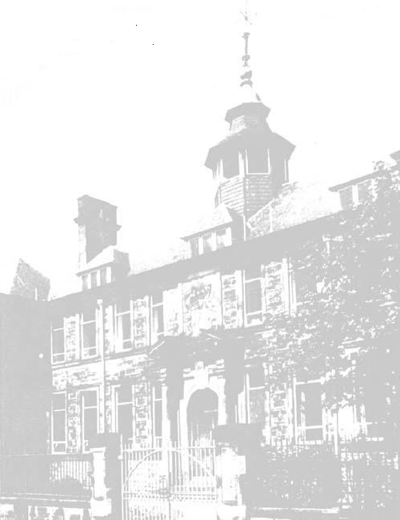

Dalziel High School
Crawford Street
MOTHERWELL
ML1 3AG

Tel: 01698 274900

Fax: 01698 328631

DALZIEL HIGH SCHOOL

The Aims of the School

The School has a number of aims which seek to provide - in a caring, safe and orderly environment - a high quality education which meets the academic, social and moral needs, and promotes the effective personal development of all our pupils.

The School and the Community

At Dalziel, we seek to achieve our aims in partnership with parents and the whole community. There is a strong Parent Council, which meets once per month during term time, and which actively supports the activities of the School. Equally active and supportive is the Parents’ Association which raises funds to enhance the extra-curricular and other aspects of school life. The School also enjoys well developed links with the local business community - links which are to the great benefit of our pupils and the community at large.

All this helps to ensure that the spirit of co-operation and partnership between home, school and community is very strong.

The Pupils

Dalziel is very popular with parents and children and, at present, has a roll of approximately 965 - with no places available in a number of year groups. The School has three associated primaries - Knowetop, Glencairn and Ladywell - with a large number of pupils coming to the School on placing requests. The School Roll is at maximum and, by virtue of this, most classrooms are in use every period.

Members of staff enjoy individual departmental bases in which to spend preparation and correction time.
DALZIEL HIGH SCHOOL
SUMMA PETENDA

The Staff

The teaching staff numbers around 75 with the Senior Management Team comprising of the Rector and five Depute Rectors. On the curriculum side, there are 10 Principal Teachers. Pupil Support is organised in 3 Houses with the Pupil Support Team comprised of 3 PTs - one per House - and many other members of staff who have a Pupil Support commitment.

Dalziel High School also contains a Hearing Impaired Department which is staffed by 9 teachers and is under the line management of one of the Depute Rectors. This Department is highly valued in the School, and with hearing impaired pupils attending from a wide catchment area, has the distinction of achieving great success in fully integrating these pupils into the mainstream curriculum.

In addition, the School is extremely well resourced and enjoys the help of a Librarian in a well equipped Library/Resource Centre.

Staff - Pupil Relationships

Staff-pupil relationships in Dalziel are excellent and these are characterised by genuine warmth as well as mutual respect. Visitors often remark that they feel a sense of calmness and friendliness about the School on coming through the front door. It is, without doubt, a very good school in which to work - but it is, by no means, an easy school in which to work. Classes are invariably large (many at maximum size) and all associated with the School have high expectations.

AIM FOR THE HIGHEST

DALZIEL HIGH SCHOOL

The Dalziel Tradition

Dalziel has a strong tradition attached to it - a tradition which is very much alive and well reflected in the multitude and variety of extra-curricular activities associated with the School. These do not involve simply the spectrum of ‘normal’ activities eg football, rugby, hockey, orchestra, choirs, chess, guitar etc but also extends to School Shows (Junior and Senior), School Sports, School Magazine, Public Speaking, Quizzes, Dances, Burns Supper, Talent Show etc, all of which are hugely popular and extremely well supported. This, in itself, generates further enthusiasm and gives a great feeling of satisfaction and pleasure to all associated with them.

It is testimony to the efforts of all associated with Dalziel that we won the CoSLA Award for ‘Excellence Within the Organisation’ and also were awarded the highly prestigious Customer Service Excellence Award by the Government - both of which underline the hard work and commitment of so many people. Dalziel has also achieved Gold Status as a Health Promoting School.

Life Beyond the School

When leaving school, pupils have the good fortune to be able to join the FP Association which ensures that their talents can be further nurtured in a number of activities - football, rugby hockey and amateur musicals/dramatics. These activities take place at Dalziel Park - an estate administered by Dalziel High School War Memorial Trust. This has undergone a major redevelopment and we are very proud that Dalziel now has the best facilities on offer in the country.

The successful candidate, therefore, will require to show the same commitment and enthusiasm to join in all aspects of life and work in Dalziel that is the hallmark of the present staff.

