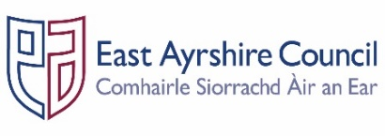
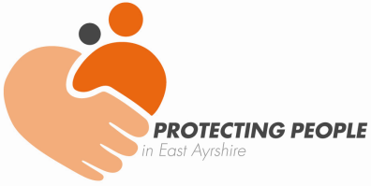
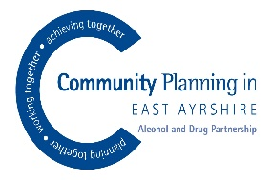

Job Outline and Person Specification

Post: Independent Chair - East Ayrshire Alcohol & Drugs Partnership

Accountable to: East Ayrshire Integrated Joint Board, Community Planning
Partnership & Chief Officer Group

Reporting to: Chief Executive, Director of Health & Social Care Partnership or
delegated Head of Service

Professional link: Senior Manager – Protection & Learning

Job Purpose: The Independent Chair will be responsible for providing leadership, direction and co-ordination of the multi-agency Alcohol & Drugs Partnership Committee (ADP), within the East Ayrshire Community Planning Partnership, ensuring the delivery of the East Ayrshire Alcohol & Drugs Strategic Improvement Plan.

- KEY DUTIES & RESPONSIBILITIES

- Chair East Ayrshire’s multi-agency Alcohol & Drugs Partnership Committee, ensuring appropriate representation and ensure all work is undertaken in accordance with relevant Scottish Government legislation and policy.

- Represent East Ayrshire’s Alcohol & Drugs Partnership as required at East Ayrshire Integrated Joint Board and Chief Officer Group.

- Ensure that the Alcohol & Drugs Partnership fulfils its key functions as outlined in the Terms of Reference, in respect of strategic planning; continuous improvement; public information and engagement and communication.

- Ensure continuous engagement between partners and all other stakeholders by promoting and developing multi-agency working arrangements and practices in respect of adult protection.

- Lead and support the development of an Alcohol & Drugs Partnership Annual Report and the Strategic Improvement Plan for the Alcohol & Drugs Partnership.

- Lead and support the Alcohol & Drugs Partnership Committee to commission services within the resource allocated in order to deliver the outcomes of the ADP Strategic Improvement Plan.

- Ensure that proportionate self-evaluation plan and improvement/development plans are in place along with implementation arrangements.

- Promote the development and implementation of drugs and alcohol awareness campaigns to ensure greater understanding of the impact of alcohol and drugs on the community, families and vulnerable groups through public information and engagement initiatives.

- Provide reports to the Scottish Government and other national or local bodies as required, representing the Alcohol & Drugs Partnership Committee at a National Level when appropriate.

- Take a lead role where required in responding to media enquiries within the framework of the media protocol and in conjunction with the Alcohol & Drugs Partnership Committee and Chief Officer Group.

- Promote maximum involvement of individuals with lived experience who access services, and their families and carers, in order for there to be continuous improvement across multi-agency services which support and protect individuals at risk of harm through alcohol and drugs.

- In conjunction with the Health & Social Care Partnership commissioning arrangements for the ADP, support the measurement of the impact of services provided on a multi-agency basis and commissioned through the ADP to support people who use alcohol and drugs.

- In conjunction with the Health & Social Care Partnership budget holder and ADP Team, monitor the resource requirements to enable the Alcohol & Drugs Partnership to function appropriately, and report accordingly to the Integrated Board and Chief Officer Group.

- To ensure that the Alcohol & Drugs Partnership Committee keeps its governance arrangements under review, including the work of its sub-groups and related work streams.

- To undertake such specific remits and functions as may be required by the Alcohol & Drugs Partnership and Chief Officer Group.

- GENERAL RESPONSIBILITIES

- Account to the Community Planning Partnership, the Integrated Joint Board and the Chief Officer Group through the Director of the East Ayrshire Health & Social Care Partnership.

- Develop and maintain networks with the Scottish Government and other national bodies on the implementation and development of the Alcohol & Drugs Partnership Committee’s business.

- Ensure that the East Ayrshire Alcohol & Drugs Partnership collaborates with other similar Committees across Scotland.

This description is indicative of the nature and level of responsibilities associated with this role. It is not exhaustive and the Chair may be required to undertake other duties and responsibilities from time to time.

Person Specification
Designation: Alcohol & Drugs Partnership - Independent Chair

Attributes: | Essential Criteria | Desirable
Qualifications |  | - Relevant professional qualification  - Degree level qualification
Knowledge & Skills | - Evidence of effective leadership skills and an ability to motivate others  - An ability to engage constructively with a range of stakeholders, communicating effectively with all partners  - In-depth knowledge of the legislation and guidance relating to alcohol & drugs services  - Fluent report writing and effective presentation skills  - Ability to work autonomously using own initiative and as part of a team  - Ability to analyse situations, make decisions and reach independent judgements  - Able to prioritise a workload and meet deadlines  - Strong personal values, rooted in respect and valuing people  - Able to exercise sound judgement in complex matters  - Emotionally responsive to the impact of complex work with all partners involved  - Ability to maintain confidentiality  - Able to prioritise a workload and meet deadlines | - Knowledge of local and national government  - Knowledge and understanding of the role and function of Community Planning Partnerships  - Knowledge of the role of the Alcohol & Drug Partnership Committees  - Virtual chairing and meeting delivery skills  - Evidence of continuous professional development throughout career  - Good IT skills
Experience | - Extensive work experience at senior management level  - Partnership working in a multi-agency capacity or across multi-disciplinary teams  - Working effectively with small teams and working groups  - In depth experience of working within the area of alcohol and drugs  - In depth experience of the legislative and policy frameworks across public protection  - Implementing policies, procedures and standards  - Chairing of multi-disciplinary groups and meetings | - Experience of frontline service delivery in alcohol and drug services or experience of using alcohol and drug services

NB The role necessarily involves travel to and within East Ayrshire and nationally to undertake work and attend meetings.

