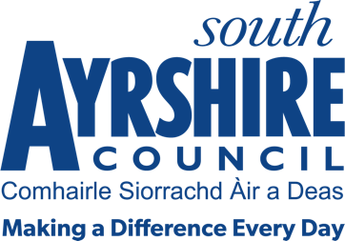



Job Title Principal Educational Psychologist

Level Principal Psychologist Management Spine

Service Education

Job Purpose

The Principal Educational Psychologist is responsible for the overall strategic direction, management and quality assurance of the Service.

Date: 7 December 2017

Job Description

Post Responsibilities:

- Ensuring there is a cohesive and strategic vision for Psychological Services which links to national and local priorities
- Direct the Psychological Service and formulate, implement, monitor and evaluate its aims and objectives with self-evaluation being a key priority.
- Supervise and direct the core functions of the Service and ensure compliance and statutory obligations for the Service and all its staff..
- Work in partnership with other staff within the Council and with and appropriate establishments and agencies to meet the needs and improve outcomes for children and young people.
- Work strategically across the Council, and support Psychological Services staff to lead programmes, initiatives and working groups to improve outcomes for children and young people
- Raise the profile of educational psychological services across the Council
- Participate in the selection and appointment of staff to the Service.
- Manage and deploy the staff of the Service.
- Promote the professional development of staff, provide advice and programmes of training tailored to the individual needs of staff and operate structures which permit participation by all members of staff in the development of the Service.
- Ensure that appropriate arrangements are made for the management of finances of the Service within the agreed budgetary limits.
- Manage the health and safety of all Service staff.
- Expected to travel efficiently and effectively between various work locations.
- Carry out duties consistent with the post as may be required by your Line Manager.

Possession of:

- Chartered Educational Psychologist
- HPC registered

Substantiated ability to:

- Work in a situation where there may be competing demands and pressures on limited resources.
- Work effectively with different agencies to the benefit of the child and the young person.
- Communicate clearly and effectively both in writing and orally with various stakeholders.
- Communicate a clear and strategic vision of the role of Psychological Services at both local and national levels.
- Strategically analyse data to inform next steps for service delivery.
- Meet the standards required under the Values and Behaviours of South Ayrshire Council.

Demonstrable experience of:

- Working strategically and with partners to impact effectively on the outcomes for children and young people.
- Working with children and families in an educational context.
- Successfully leading a team to improve outcomes for children and young people.
- Self-evaluation and improvement.
- Inclusive education and interagency working.
- Supporting the professional development and building capacity in others both within a team context and across the local authority.

In terms of the Protection of Vulnerable Groups (Scotland) Act 2007, this post is designated as
Regulated Work. Consequently, in order to undertake the duties of this post, you must hold Membership of the Protecting Vulnerable Groups (PVG) Scheme.

If you are charged with any offence or are involved in any activity which may have implications for your membership of the PVG Scheme, you must immediately notify your Line Manager.

Applicants must be able to recognise, and report concerns about the wellbeing of children and vulnerable service users and be able to maintain appropriate professional relationships with service users.

