Job Outline
Post: Ecology Officer (Nature Conservation)
Location: Inverness / flexible working*
Hours: 35 hours per week
Duration: Full time, permanent
Service: Infrastructure, Environment & Economy
Grade: HC 08 (£38,474 - £41,714)
Contact: Andrew Puls
e-mail: Andrew.puls@highland.gov.uk

*The post location will be a combination of both home and office. The postholder will be required to attend regular meetings in Inverness with regular site visits across the region.

Job Purpose :
As part of the ecology team led by the Senior Ecology Officer, you will work closely with a wide range of services, stakeholders and partners both within and outwith the Council to deliver biodiversity improvements and nature-positive projects across Highland. You will help deliver the Council’s Ecology Strategy and will lead and/or input into a wide range of biodiversity projects and initiatives.
A key focus of the role will be to work closely with the Council’s Amenity Services team to implement a strategic approach to improving the biodiversity value of Council land and delivering nature-positive enhancements across the Council estate. This will include leading on the Greenspace Management Strategy and formulating Council policy and guidance.
You will assist in the management of the Nature Restoration Fund, work with communities and stakeholders to develop new Local Biodiversity Action Plan/s and liaise with Councillors to further promote the Species Champions Initiative.
You will liaise and work closely with local communities to ensure biodiversity is recognised and considered in decision making, e.g. promoting wildlife-friendly community food growing, contributing to community planning partnerships, working to implement the Council’s vision to establish ‘Biodiversity Villages’, and support the work of the Highland Environment Forum and Local Biodiversity Action Groups.
You will seek new opportunities to secure external funding for both terrestrial and marine biodiversity projects and help promote biodiversity and publicise outcomes through PR, social media and online.
You will also have the opportunity to assist the Ecology Survey Team to undertake ecological survey work across Highland and to feed into existing projects to identify and map Nature Networks and designate Local Nature Conservation Sites.

Further Information
This is an exciting opportunity to join the Council’s Ecology Team. The successful candidate will have the opportunity to work with services across the Council and local communities across Highland to promote and deliver nature-positive projects, delivering significant biodiversity improvements across the area.
The successful candidate will be a focussed and driven individual with a degree in ecology or a related discipline and an in depth understanding of biodiversity, and a particular interest in grassland management. You will be confident recognising Highland’s habitats and species and assessing their significance, able to identify and quantify impacts and agree, modify and/or design appropriate strategies. We will ensure that your skill set is maintained with regular CPD and skill development and will assist the postholder in developing new ecological skills, knowledge and understanding where required.
Employee Benefits
The Highland Council is committed to their employees and offers an excellent benefit package that can include:
- Flexible working patterns including both full-time and part-time opportunities. We want to accommodate the right candidate for the post and we are able to assist life style choices and other commitments you may have. For example: seasonal compressed hours
- Competitive salary with an incremental scale and annual pay review.
- Wide range of learning and development opportunities with an annual review to discuss career opportunities and progression.
- 28 days paid holiday plus 7 Public paid holiday (pro rata for part-time staff), rising to 33 days paid holiday (pro rata for part-time staff) after 5 years continuous service at the commencement of the next leave year.
- Pension Scheme, including employers contribution of 19.5%
- A genuine commitment to the health and wellbeing of our employees with access to the new Employee Assistance Programme.
- Family Friendly staff policies including Parental Leave.
- Employee discount/reward schemes from major and local retailers.
- Cycle to Work scheme.
If you are interested in working for Highland Council and being part of a team providing a first-class service please view the further information, job description and person specification and then apply online.
The Highland Council - Ambitious, Sustainable and Connected.
The Highland Council vision is to be an ambitious, sustainable and connected Highland. The Council’s goal is for the Highlands to be best place to live, to visit and to invest in. The Council recognises that the climate and nature crises are interlinked and reinforcing; biodiversity loss is identified as a corporate risk and reversing biodiversity loss is a key action of the Council’s Net Zero Strategy and forthcoming Ecology Strategy. The Council is responsible for the conservation, restoration and enhancement of biodiversity through its planning function, across its own estate, through the delivery of policy, strategy and guidance and working with partners, communities and stakeholders.
- Structure Chart –
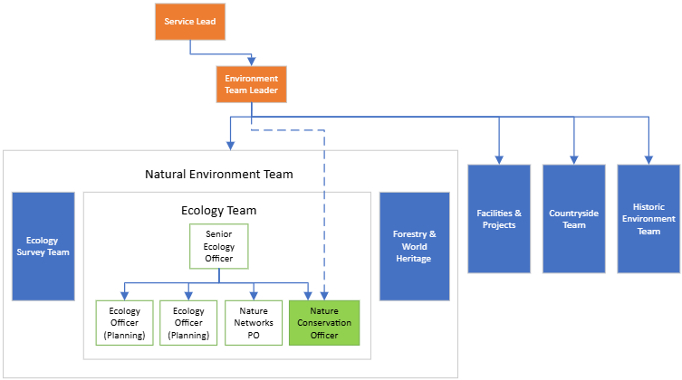
- Job Description – Key Duties and Responsibilities
- Be the primary point of contact for providing advice to the Council in relation to improving the Council estate for biodiversity, including developing Council Greenspace Strategies and policies and developing and contributing to individual site management plans.
- Work closely with Amenity Services (and other Council services as required) to identify opportunities to integrate nature-positive management into the Council estate, and to put in place plans and protocols to ensure that future management delivers for biodiversity.
- Provide specialist and professional advice on ecological issues, maintaining up-to-date knowledge of legislation, policy and current good practice.
- Lead a community centred engagement approach to develop Local Biodiversity Action Plan/s for the Council area.
- Provide input and advice in relation to internal and external projects, including those funded through the Nature Restoration Fund, and for projects delivering biodiversity improvements across the Council estate.
- Lead on the delivery of a wide-range of biodiversity projects and assist the Council in delivering the actions of the Scottish Biodiversity Strategy and the Council’s Ecology Strategy.
- Identify external funding opportunities and complete funding applications.
- Support the work of and represent the Council at the Highland Environment Forum.
- Assist the wider team as required in, for example, survey and mapping of Nature Networks, designation of Local Nature Conservation Sites and ecological survey work.
- Provide specialist officer representation on internal and external working and steering groups and provide ecological input to services, partners, stakeholders and communities involved in tackling the climate and ecological emergency.
- Provide information on and respond to enquiries from Council officers, elected Members, partners, developers and the public.

- Other Duties

The postholder may be required to perform duties, appropriate to the post, other than those given in the job description. The particular duties and responsibilities attached to posts may vary from time-to-time without changing the general character of the duties or the level of responsibility entailed. Such variations are a common occurrence and would not themselves justify reconsideration of the grading. As a result of such variations, it will be necessary to update this job specification from time-to-time.
- Person Specification

EXPERIENCE

Excellent knowledge of biodiversity in the Highlands, the causes of decline and experience of implementing conservation strategies

Botanical knowledge and an understanding of grassland management and how biodiversity enhancement (across a range of habitat types and contexts) can be implemented in practice.

Working with a wide range of stakeholders to promote and restore nature, including Council services, local communities, community groups, and government agencies.

Up-to-date knowledge of relevant legislation, local and national strategies and relevant policy/guidance and experience of applying these in practice.

Experience of practical ecological fieldwork and survey and in-depth knowledge of survey techniques, principles and methodologies.

Experience delivering projects successfully to time and budget.

Experience of applying for external funding.

Experience of using biological records and other sources of ecological data.

Understanding of the relationship between spatial planning and wider rural issues including land management.

Demonstrable skills in accurate collection, analysis, interpretation and presentation of data and information.

EDUCATION AND QUALIFICATIONS

A degree in ecology or a related discipline.

Evidence of a continuing commitment to personal and professional development.

Membership of a relevant professional body, or commitment to work towards such.

SKILLS:

Ability to undertake a habitat survey to at least Phase 1 Habitat Survey level.

Ability to identify opportunities for biodiversity enhancement within the council estate in accordance with the mitigation hierarchy, industry legislation and good practice guidelines.

Ability to understand complex information and write technical reports including detailed Habitat Management Plans and Biodiversity Action Plans.

A practical understanding of biodiversity enhancement metrics and their application in practice.

Excellent interpersonal skills including the ability to negotiate, influence and persuade.

Excellent written skills and ability to write professionally, clearly and succinctly in a wide variety of contexts.

A high level of IT competency. A working knowledge and understanding of GIS (QGIS would be an advantage) and all standard MS Office applications.

Ability to safely undertake site visits across Highland including in remote locations.

A full UK driving licence or access to transport.

ESSENTIAL ATTRIBUTES:

A team player comfortable working with a wide range of people from fellow officers and Council managers to developers, consultants, elected Members and the public.

Self-motivated, ability to work independently and comfortable exercising own initiative. You will be able to independently solve problems and identify and deliver service improvement opportunities.

Able to work flexibly and under pressure, with ability to prioritise a large and varied workload with competing demands and deadlines.

- Health and Safety
Health & Safety is an integral part of any role within the Highland Council. As such we would expect that all employees:
- Become familiar with Violent Incident and Accident reporting procedures and comply with them.
- Undertake a continual program of Risk Assessment in relation to their role within Highland Council
Have an understanding of the importance of Health and Safety in the workplace, and familiarise themselves with the Highland Council’s Health & Safety Procedures.
