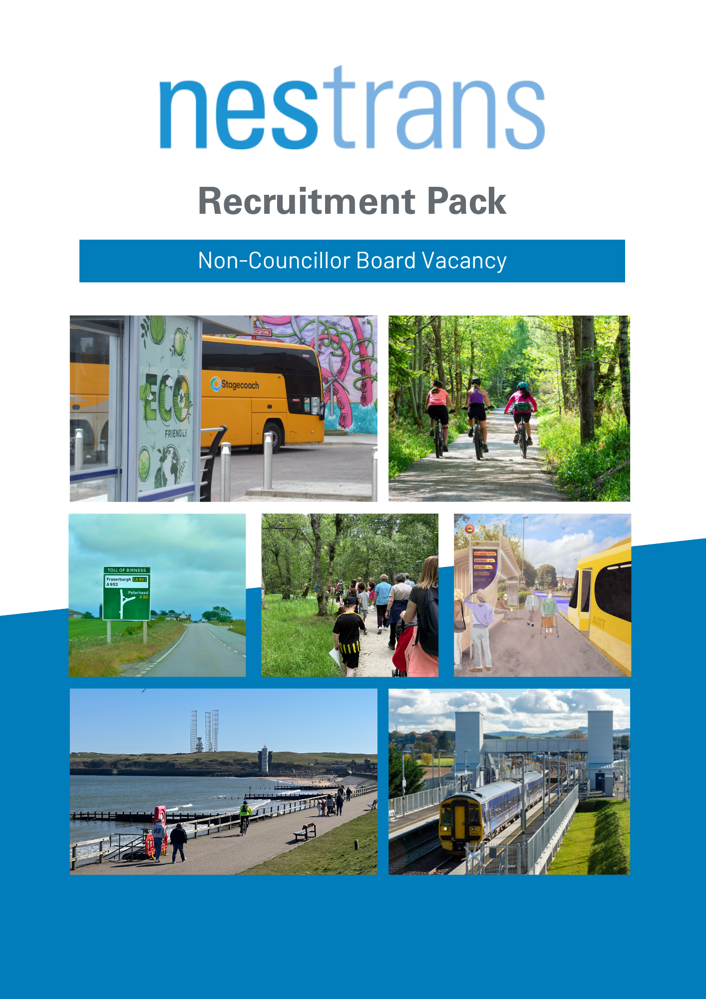

Welcome

Thank you for taking the time to download this pack and learn more about becoming applying to become a member of the Nestrans Board.

Nestrans is the Regional Transport Partnership (RTP) for Aberdeen City and Aberdeenshire, forming one of seven statutory RTPs across Scotland. RTPs take a strategic approach to transport planning and delivery across their respective regions, linking both to national policy direction, but also to local objectives. Our website is www.nestrans.org.uk

Our purpose is to develop and deliver a long-term Regional Transport Strategy and take forward strategic transport improvements that support and improve the economy, environment and quality of life across the North-east. Our current Strategy was approved in 2021, setting out a vision to 2040 across different sectors and transport modes, with the following objectives:
- Improved journey efficiencies to enhance connectivity;
- Zero fatalities on the road network;
- Air quality that is cleaner than World Health Organisation standards for emissions from transport;
- Accessibility for all;
- A step change in public transport and active travel enabling a 50:50 mode split between car driver and sustainable modes.

Our Board consists of eight councillor members, four nominated by each of the constituent councils and four non-councillor members. Non-councillor members serve an important purpose on the Nestrans Board, helping to promote a wider range of perspectives around the table, as well as a detachment from local and national politics.

This appointment is an opportunity to join the board at an exciting time for transport in the north east, with new funding programmes such as our People and Place active travel behaviour change programme, developing proposals for Aberdeen Rapid Transit, our work with NHS Grampian on Health and Transport, and business cases being progressed for infrastructure upgrades on key transport links. If you are successful in your application, you will be working with board to help shape the delivery of the Regional Transport Strategy; ensuring that our transport system supports the future needs of the region.

If your application is shortlisted for interview, you will be invited to meet with our Appointments Committee in October to discuss your application.

As a mid-term appointment, the appointment of this post will run until October 2029, subject to review after two years, from the date of appointment. The successful candidate is expected to attend five board meetings a year with the possibility of some additional informal meetings or workshops.

If you have any questions or queries about the work of Nestrans or your application, please do not hesitate to get in touch.

Please note that you are required to submit your full application by close of business on Friday, 19 September 2025.

GUIDANCE FOR COMPLETING YOUR APPLICATION FORM

- Candidates must complete their application form to match their skills and knowledge against the specified criteria.

- Remember to use specific examples which you think relate to the post to support how your knowledge and skills meet the criteria.

- Remember to structure your response in terms of the essential criteria.

Before returning this application form you may find the checklist below to be of some assistance. Forms returned electronically will require to be signed personally before any appointment can be made.

Application form signed and dated | ☐
Public Appointments Monitoring form signed and dated | ☐
Political Activity Declaration form signed and dated | ☐
Application form has the names, addresses and telephone numbers of two referees | ☐
Ensure that any documents you have referred to are returned with the application form. An application in the form of a CV is not acceptable. | ☐

Key Dates:

- Application Deadline: 5pm, Friday, 19 September 2025

- Interview with Appointments Committee: Thursday, 9 October 2025

- Date of first Nestrans board meeting: Wednesday, 12 November 2025

Please note that an induction session for the new member will be arranged for the successful candidate prior to the first board meeting, at a mutually convenient time.

Submitting your application:

By Post: | By Email:
Ewan Wallace  Head of Environment and Sustainability  Environment and Infrastructure Services  Aberdeenshire Council  Woodhill House  Westburn Road  Aberdeen  AB16 5GB | Ewan Wallace  ewan.wallace@aberdeenshire.gov.uk

Please complete this form ensure it is signed and dated and all enclosures are attached. You should fill in the form as completely and as clearly as possible. Please do not substitute your Curriculum Vitae for a completed form since this will not be considered. This is to enable us to consider applications on an equal basis.

APPOINTMENT: MEMBER OF THE NORTH EAST SCOTLAND TRANSPORT PARTNERSHIP

NAME AND ADDRESS
Surname | Title
Forenames
Permanent Address

Telephone Number
Post Code
Email address
Professional Qualifications (if any)
Occupation
Address for correspondence (if different from above)

Post Code Telephone Number

SUITABILITY FOR APPOINTMENT

Drawing on either your working life or personal life, please describe how your skills and knowledge meet the criteria set out below.

Personal and/or operational expertise and demonstrable knowledge from working at board/strategic level in business, the public sector or the voluntary sector

Detachment from local and national politics

Transport knowledge (this could be knowledge of the transport issues pertinent to one or more sector e.g. business, public health, the environment, economic development, community planning etc)

Regional rather than local perspective

Political and media awareness

Financial awareness

Communication skills

PRESENT AND PREVIOUS PUBLIC APPOINTMENTS

Do you hold or have you held an appointment in a public, voluntary or community organisation?

Yes No

If ‘Yes’, please list below the organisations, length of time, positions held, and any remuneration received. Please state the type of organisation in which you held the appointment, continuing a separate sheet if necessary.

Name of Public Body | Period of Appointment |  | Position (e.g. Chair, Member) | Remuneration received for current posts
Name of Public Body | From | To | Position (e.g. Chair, Member) | Remuneration received for current posts

If you are currently holding, or have held, a public appointment we may take up a reference from the Chair.

DECLARATION OF INTERESTS

Are you aware of any possible conflict of interest which might arise, either personally, in relation to your employment or in relation to your connections with any individuals or organisations should you be appointed? Conflicts of interest are not normally a barrier to appointment as long as they are appropriately managed and/or resolved and this will be explored at interview.

e.g.:
- Perception of rewards for past contributions or favours;
- Relevant pecuniary or other interests outside the organisation;

Yes No

If ‘Yes’ please give details

ADVERTISING & PUBLICITY

From which source did you learn of this vacancy?

If nominated, please state name of nominating body

(A nominating body is an organisation which is invited to put forward suggested names for consideration. Nominees go through the same selection process as candidates applying through open advertisement.)

REFEREES

Please provide details of two referees whom we can approach about your application for appointment if you are selected for interview.

Name | Name
Position | Position
Address | Address
Telephone No.  (including area code) | Telephone No.  (including area code)

DECLARATION

I declare that the information I have given in support of my application is, to the best of my knowledge and belief, true and complete. I understand that if it is subsequently discovered that any statement is false or misleading, or that I have withheld relevant information, my application may be disqualified.

Under the terms of the Data Protection Act 1998, I agree that the information given in the application and monitoring forms may be processed to provide management information for appointment and equal opportunities monitoring purposes.

Signature |  | Date

Notes:
- If you are submitting this form electronically please leave the signature line blank. If you are shortlisted for interview you will be asked to sign the declaration before the interview takes place.
- The personal information provided by you will not be disclosed by Nestrans to third parties. We may however publish statistical information relating to public appointments which will be based on information gathered from these forms but will not identify any individuals.
POLITICAL ACTIVITY

All applicants for a public appointment should complete the question below. This question is asked as it enables the monitoring of political activity of candidates for a public appointment in so far as it is already in the public domain. Neither activity nor affiliation is a criterion for appointment (except where statute dictates specific representation).

If you are successful, the information provided will be published with the announcement of your appointment.

Please indicate which of the following activities you have undertaken during the past 5 years by ticking the appropriate box and by providing details of your involvement. Name the party or body for which you have been active. If you have been or are an Independent or have sought or obtained office as a representative of a particular interest group, you should state this. You should tick all relevant categories.

a. Obtained office as a local councillor, MSP, MP, MEP etc.
Stood as a candidate for one of the above offices
Spoken on behalf of a party or candidate

b. Acted as a political agent
Held office such as Chair, Treasurer or Secretary of a local branch of a party
Canvassed on behalf of a party or helped at elections
Undertaken any other political activity which you consider relevant

c. Made a recordable donation to a political party1

d. None of the above activities apply

Name of Party for which activity undertaken

Details of involvement:
Name |  | Signature |  | Date

Note: This form is for monitoring purposes only and therefore will be detached from your application and will not be seen by any selection panels. However, it is appreciated that such activities may have given you relevant skills, including experience gained from committee work, collective decision making, resolving conflict and public speaking. If, therefore, you have had such experience and you consider it relevant to your application for this post, you should include it separately in the main body of your application form.
PUBLIC APPOINTMENTS MONITORING FORM

From time to time we are asked to provide information, in summary form only, on age, gender, ethnic origin and disability in response to Parliamentary Questions and other public enquiries. The Data Protection Act 1998 requires that those providing the information must be informed and their consent given.

AGE AND GENDER

Male Female Date of Birth:

ETHNIC ORIGIN & NATIONALITY

Please indicate ethnic origin and nationality (either by ticking the relevant box, or in your own words):

A White

Scottish
English Welsh Irish
Other white background (please specify):

B Mixed

Any mixed background (please specify):

C Asian – Asian Scottish, Asian English, Asian Welsh or other Asian British

Indian Pakistani Bangladeshi Chinese
Other Asian background (please specify):

D Black – Black Scottish, Black English, Black Welsh or other Black British

Caribbean
African
Other black background (please specify):

E Other Ethnic Background

Other background (please specify):

DISABILITY

Are you disabled? Yes No

Do you consent to the information you have provided above being made publicly available (in a summarised format)?

Yes No

If you prefer not to answer any of the monitoring questions detailed on the previous page, please tick here

I confirm that I would like to be considered for the specified public appointment and that the information given on this form is complete and correct and may be processed accordingly.

Signature
Name
Date

Please Note:

- The information on ethnic origin does not form part of the selection process (see accompanying letter).
- If you have indicated that you are disabled, please see the enclosed details of the guaranteed interview scheme for disabled candidates.

GUARANTEED INTERVIEW SCHEME

Nestrans is committed to Equal Opportunities and welcomes
applications from disabled people.

Nestrans is committed to ensuring that disabled people are given every opportunity to contribute to the governance of Scotland by serving as a chair or non-executive member of the boards of public bodies. We guarantee an interview to anyone with a disability whose application meets all the essential criteria for the post.

The essential criteria are those detailed in the publicised Person Specification for the post in question. The decision on whether a candidate satisfies the essential criteria will be determined by the Advisory Panel for the post.

What do we mean by disability?

To be eligible for the guaranteed interview scheme you must consider yourself to have a disability as defined by the Disability Discrimination Act 1995 or consider that you have a disability that affects the work you can do (but which does not fall within the definition contained in the Act).

How do I apply?

Complete the declaration below and return it along with your completed application. Please also provide details of any assistance required at interview.

DECLARATION

I would like to apply under the guaranteed interview scheme as:

I have a disability within the meaning of the Disability Discrimination Act 1995

I have a disability/health problem that affects the work I can do

Please give details

Name
Address
Date
Signature

ASSISTANCE FOR INTERVIEW

To ensure we do not create any barriers in our selection process and to help us implement our equal opportunities policy effectively, please let us know if you would like us to provide any particular assistance for your interview, such as:

Please Tick
Induction loop
Sign language interpreter
(please specify type):
Keyboard for written tests
Someone with you at the interview, e.g. speech facilitator
Car parking
Assistance in and out of a vehicle
Wheelchair access
Accessible toilet facilities
Other assistance (please specify):

If you have any questions about your specific needs at the interview or would like to give us more information, please contact Paul Finch, Nestrans, Archibald Simpson House, 27-29 King Street, Aberdeen, AB24 5AA

1The Political Parties, Elections and Referendums Act 2000 requires the Electoral Commission to publish a register of recordable donations (donations from any individual totalling more than £5,000 in any calendar year, or more than £1,000 if made to a subsidiary accounting unit such as a constituency association, local branch, women’s or youth organisation). These provisions became effective from 16 February 2001.

