SCHOOL PROFILE
Turnbull High School
St Mary’s Road, Bishopbriggs, Glasgow, G64 2EF
Tel: 0141 955 2393
Fax: 0141 772 8016
Head Teacher: Eileen Kennedy

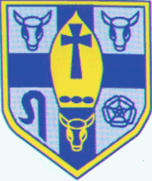
Our Vision
As a community of faith and learning, centred on Christ, we will value each person as an individual, enabling our student to fulfil their potential as young men and women, prepared to meet the challenges of life and committed to serving Christ in others.

Our Values
The values of the Gospel will direct the work of the school. Our community will aspire to:
- grow in faithfulness to God
- encourage hope in each person
- reach out in compassion to others
- respect the dignity of all
- treat others fairly
- act with honesty

Our Aims
We will strive to achieve our vision by:
- providing high quality Catholic education based upon Gospel values
- providing experiences which meet the individual needs of our young people and enable them to achieve their full potential
- fostering a strong sense of community within the school and developing productive links with the wider community
- valuing and developing all members of the school community.

Catchment Area
Turnbull High School is situated in Bishopbriggs and caters for pupils from St Helen’s Primary School and St Matthew’s Primary School in Bishopbriggs and pupils living in Torrance who attend St Machan’s Primary School in Lennoxtown. Pupils from, St Nicholas’ Primary School in Bearsden have an entitlement to places in Turnbull. Our roll is approximately 650, with each year group being capped at 120.

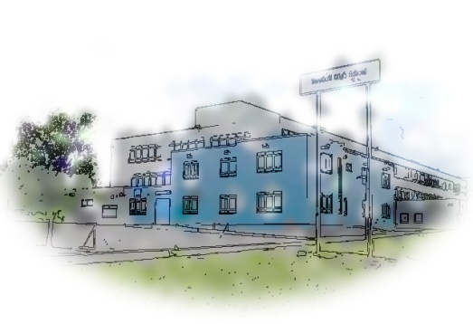
Turnbull High School
St Mary's Road, Bishopbriggs Glasgow G64 2EF
Tel: 0141 955 2393
Fax: 0141 772 8016
Email: office@turnbull.e-dunbarton.sch.uk
Head Teacher Eileen Kennedy
Turnbull High School
St Mary's Road, Bishopbriggs Glasgow G64 2EF
Tel: 0141 772 9101
Fax: 0141 762 3671
Email: office@turnbull.e-dunbarton.sch.uk
Head Teacher Neil Roarty M.A.

Staffing
The Senior Management Team consists of the Head Teacher, and four Depute Head Teachers. There are 14 Principal Teachers of Curriculum as well as five Principal Teachers of Pupil Support providing support to pupils through a vertical guidance system. The total teaching staff is approximately 54.5 FTE. The teaching staff are supported by the School Support Manager, 5.4 office staff, 2 Facilities Officer, 2 Site Co-ordinators, 4 Technicians, 1 Librarian, 2 School Assistants, 5.18 Pupil Support Assistants and a Chaplain.
Parents
The school values the contribution of all parents and seeks to work in partnership with them. The Parent Council and the PTA both play an active and supportive role in the life of the school. The views of parents are sought as part of our self-evaluation processes. The school communicates with parents through regular newsletters, leaflets, information evenings as well as reporting evenings and profiles.

Community
The school has developed close working links with local parishes and our spiritual life is enhanced significantly by the work of our chaplain, Rev Father Nicholas Monaghan. This work is very much supported by Canon Robert Hill. The school band and choir are active in the local community, while during Advent and Lent, pupils raise funds for local and international charities. As part of our Eco Schools programme, we encourage pupils to support anti-litter campaigns. We aim to encourage young people to make a difference to society while at school and in their adult lives.

Extra-Curricular Activities

Pupils participate in a wide variety of extra-curricular activities, including – football (girls and boys), netball, chess, athletics, Art Club, public speaking and rugby. The school also has an impressive musical tradition and comprising a Big Band, Jazz Band, and Choir. Local and international excursions are also a feature of school life.
The Fair Trade, St Vincent De Paul and Pro-Life groups are active in the school and the local community.

