
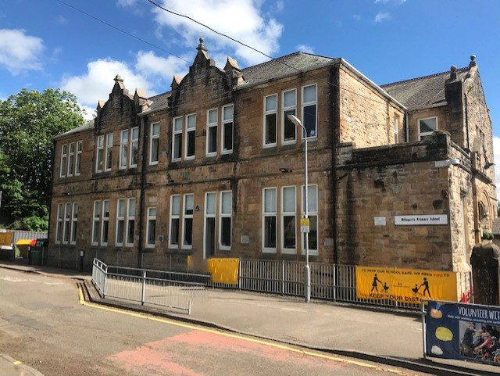

Milngavie Primary School Profile

5 Hillcrest Street

Milngavie

G62 8AH

Tel: No: 0141 955 2251

Head Teacher Mr Garry G Graham

Staffing 2 Depute Head Teachers 1 Principal Teacher
18.35 FTE Classroom Teachers (including Support and Challenge
and 4 specialist staff covering NCCT) 0.2 Support for Learning Teacher
1 Nursery Teacher 1 Depute Head of Centre 1 Senior Early Years Worker 7 F/T & 4 P/T Early Years Workers 2 Early Years Support Workers

Ancillary Staff Building Manager 1 Admin Assistant
4 Classroom Assistants 3 Clerical Assistants inc EYC
4 Support for Learning Assistants 4 cleaning staff
2 Housekeepers (1 school/1 EYC) 4 Catering staff

Visiting Staff Visiting tutors for cello, violin, flute, clarinet, brass and chanter
Network Learning Support– 1 day per week

Roll School roll is currently 366 (as at May ’25)
Nursery Class 64 pupils on role.
Age range 3 to 12 years

Classes P1R1 P1R4
P2/1R2 P2R3
P3R5 P3R6
P4R7 P4R8
P5R9 P5R10
P6R11 P6R12
P7R13 P7R14

Site & Building
Milngavie Primary School is a non-denominational school which opened in 1875. It is situated in a conservation area at the eastern end of the pedestrian precinct in the heart of Milngavie village. It offers equal opportunities to all – the full curriculum being available to every pupil.

Set amidst mature trees the two sandstone buildings house the infant department (P1-3) and the upper school (P4-7). In 1997 a nursery facility was constructed and this can accommodate 44 children in each session.

The upper school building houses an IT suite used by all pupils. Each of our buildings is self-contained having its own playground, assembly hall/gymnasium and work areas. We are fortunate to have a further separate dining room resulting in no interference with school timetables.

Aims
The school endeavours to reflect a caring and supportive environment where a pupil’s self-esteem is nurtured and where emphasis is on striving towards self-discipline and positive values.

To prepare our young people for the world of life and work we focus on building resilience. For each child we aim to provide a broad curriculum which is stimulating, challenging and ensures progress, taking account of the age, aptitude and ability of each pupil. We work in partnership with parents to ensure a positive contribution to the social, emotional and educational development of our pupils.

Staff Development
Staff are encouraged to attend professional learning to update/increase their knowledge and skills whenever possible. In Service days are geared towards National, Authority and School priorities.

Curriculum
The school has a positive ethos where hard work, appropriate behaviour and the enjoyment of learning and success are regularly recognised and celebrated. Citizenship and sense of community are promoted and encouraged. This approach underpins all curricular areas.

The school implements Curriculum for Excellence in Language, Languages (French, Spanish, Mandarin, Gaelic and Latin) Mathematics, Health & Wellbeing, Expressive Arts, Social Studies, Sciences and Technologies.

We have a range of resources to support learning which are continually being developed to provide structure, balance and progression whilst at the same time encouraging teaching staff to be creative and innovative.
Through our improvement plan we are constantly striving to further enhance our practice to impact on specific areas of attainment and achievement.

In addition the early stages are about to embark upon an accelerated teaching programme of phonics. Collaborative learning, active and play based learning and assessment is for learning strategies are being developed throughout the school. All of these approaches will help us to strive for excellent standards of achievement and attainment for our pupils.

Our pupils with additional needs in learning, behaviour or personal and social development are supported by staff and by differentiated learning programmes, delivered as part of class, group or individual activities as appropriate. The school organises lunchtime and extra-curricular activities throughout the year.

We are committed to the philosophy of continuous improvement of every aspect of the school's work and life. We work hard to maintain positive partnerships with parents, carers and outside agencies for the benefit of the individual child and the school community.

Links with the Community
Church services are held three times per session and our school chaplain visits the school on a regular basis.
The school has a very supportive Parent Council and an active PTA who work to support the work of the school, organise events for pupils and families and at the same time raise funds for the school.
Pupil Progress Meetings are held twice yearly. Parents are encouraged, and able, to speak to staff (by appointment) if there is a concern or a need to exchange information as required. Throughout the session, class teachers use Learning Journals to keep parents informed of their child’s learning for each term, provide pupil progress reports as well as updates on the activities their child is undertaking in and out of class.

We welcome families to school events throughout the session, such as church services, concerts or productions, curriculum meetings and open days.

School Activities
Over the past few years we have been able to offer children a variety of experiences including activities such as football, netball, keep fit, shinty, coding, chess, rugby and choir. These are areas, which we are very keen to develop with the support and goodwill of staff and parents.

The views of pupils are very important to us. We are a silver Rights Respecting School working towards our Gold award. Through our Pupil Leadership programme, we have dedicated time for all pupils to participate in a range of committees aimed at supporting engagement and school improvement. This programme supports the development of our pupil’s skills for learning, life and work.

If you would like any more information on our school please do not hesitate to contact Garry Graham, Head Teacher.

