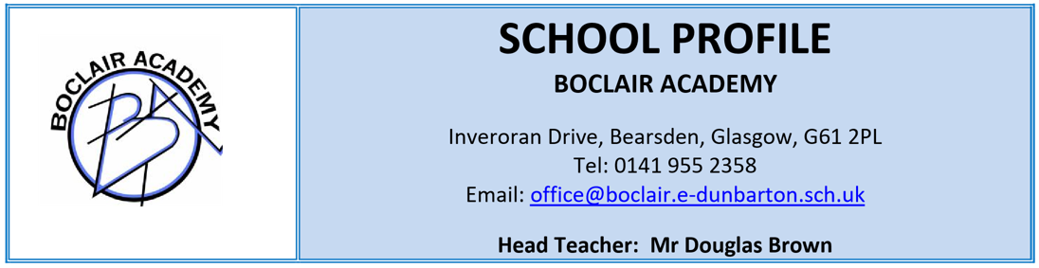

OUR SCHOOL

Boclair Academy is situated in the residential suburb of Bearsden and draws its 1050 pupils from a wide geographic area. The school has close links with its four associated primaries; Killermont, Colquhoun Park, Torrance and Westerton. Over 30% of the pupil population are enrolled as a result of placing requests, principally from North Glasgow.
The teaching complement is 76 FTE and there is a wide range of non-teaching and support staff.
The school is operating at close to maximum capacity and the classroom utilisation rate is extremely high. A full curriculum is offered at all stages of the school with emphasis being placed on continuity, coherence and progression. The high stay-on rate to S5/6 means that a wide range of courses is offered.
There is a strong commitment to ensuring that pupils are fully supported in their learning at all stages throughout the school and teaching staff participate in a range of working groups on issues such as Mental Health and Wellbeing, Promoting Positive Relationships, Learning and Teaching, Digital Learning and LGBT. We also have a strong Career Long Professional Learning programme which combines professional reading and research with in-school sessions on a variety of current education issues.

OUR VISION

Every young person at Boclair is encouraged to maximise their potential.

OUR VALUES

Following a full consultation across our community our young people chose the following values:
Respect
Honesty
Fairness
Ambition

OUR AIMS

- To provide a broad and balanced curriculum and the highest quality of learning and teaching
- To allow pupils to develop a depth of knowledge and range of skills and experiences
- To encourage pupils to take responsibility for their own learning
- To encourage pupils to participate fully in the life of the school, the wider community and society in general
- To promote an ethos of success and achievement for all
- To provide a caring environment in which pupils feel safe and secure
- To promote equal opportunities and respect for others
- To encourage parents to work in partnership with the school

AMBITION

We have a strong track record of wider achievement with an all through all-inclusive wider achievement programme. All parts of the programme are delivered with, and accredited through, an external partner. Our young people in S1 work through their John Muir Award, our S2 pupils complete a Saltire Award through their foodbank work, our S3 pupils are trained as dementia friends, our S4 pupils undertake an SCQF Level 6 qualification in Work Place Emergency First Aid, our S5 pupils work with charities as they take part in the Youth Philanthropy Initiative and all S6 pupils have an opportunity to become Interns with Medic Against Violence.

On the social, musical and sporting side there is a range of extra-curricular activities, and highlights of the school year include the Christmas dances, the S1 residential week, termly inter-class games, and visits within this country and abroad.

Over and above that we have a strong academic record with consistently high standards of results in SQA examinations. We also have a great deal of success in ensuring all young people move on from school to a positive and sustained destination.

INSPECTION

In 2020 the school was inspected by Education Scotland. The Inspection focused on two Quality Indicators: 2.3 Learning, Teaching and Assessment, and 3.2 Raising Attainment and Achievement. The Inspection Team evaluated the school as Very Good in both areas. The Inspectors identified four key strengths within the school. They determined that the school’s vision for learners was ambitious and that our pupils benefited from a supportive and inclusive learning environment. The inspection team also praised the strong relationships fostered in the school between teachers and learners. It was further found that young people attending Boclair Academy attain and achieve very well and benefited from the school’s extensive achievement programme. Finally they identified highly effective leadership across the school which leads to a very positive ethos.

THE BUILDING
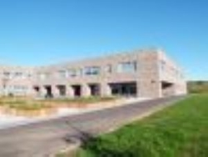

Further information related to the life and work of the school can be found on the school website and through our school twitter.

