
Midlothian Council
Teacher Job Profile

Midlothian Council

A council which works with its communities to achieve effective services and a quality environment.

Education in Midlothian
Currently, Midlothian has 6 secondary schools, 31 primary schools (19 of which have nurseries) and 4 stand alone nursery schools. Our special school, Saltersgate, provides support for children with a range of physical, social, emotional, behavioural and learning difficulties. The schools range in size from our smallest primary school with around 50 children to our largest secondary with over 1600 pupils. We have a diverse range of school catchments, from rural to urban settings. We are fortunate to have a growing number of new build schools, with 15 of our primary schools and 2 secondary having been built within the last 10 years and several new builds planned.

Job Purpose
Subject to the policies of the school and the education authority the duties of teachers are to perform such tasks as the Head Teacher shall direct having reasonable regard to overall teacher workload.
About the Role
Job Title: | Teacher – BGE Specialist (Numeracy)
Pay Grade | SNCT Main Grade Scale
Salary | SNCT Salary Table
Job Family | Teachers (SNCT)
Reporting to: | Head Teacher
Full time/Part time: | Full time
School and Location: | Newbattle High School
Permanent/Fixed term: | Permanent
Internal / External: | External
Closing date: | 04/06/2026
Interview date: | W/C 08/06/2026

To deliver quality education to assigned pupils and contribute to the professional, corporate life of the school in relation to pupils, staff and appropriate external bodies within the agreements of the SNCT.
We are seeking an enthusiastic and talented professional to contribute to our Maths Department, working specifically with our Broad General Education Cohort. The right individual will have strong people skills and be able to demonstrate their experience and skills in working as part of a team to improve outcomes for young people. Above all else, we need someone who can think creatively, has a strong work ethic, is willing to learn and who is fiercely passionate about supporting young people and their families. The right individual will have plenty of opportunities for career long professional learning and will be part of an experienced and ambitious team.

Our school vision and values of Achieve, Include, Motivate and Respect underpin everything we do, centred on supporting all young people to exceed beyond their potential. This is reflected in our school motto “Challenge” and our hashtag “#AIMHIGHER”. The school’s ethos is ambitious, inclusive and supportive.



At Midlothian Council we have developed five core people values. These values drive and

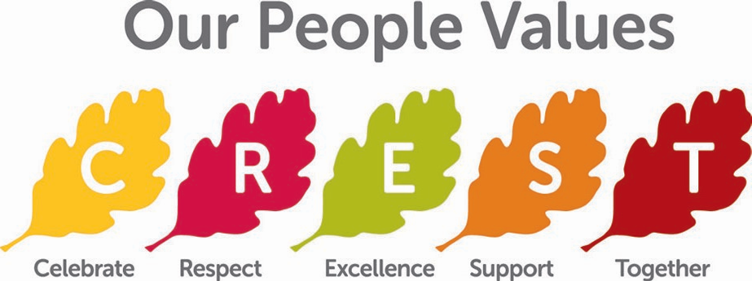

At Midlothian Council we have developed five core people values. These values drive and influence everything we do, every day in Midlothian Council.

Celebrate recognise, celebrate and share all our achievements;

Respect respect each other’s differences in a culture of trust and flexibility;

Excellence make the most of opportunities to develop ourselves and our teams to provide excellent services;

Support lead by example and be approachable and supportive of each other;

Together work together to make a difference for Midlothian

These values are key to Midlothian Council’s culture, helping us improve the way we work and make a difference to the communities we serve

Key Outcomes and Task Examples

The post holder will deliver the following outcomes: | Examples of related tasks:
Supporting School Curriculum | - Manage and organise classes through planning and preparing for teaching and learning.  - Assess, record and report on the work of pupils’ progress to inform a range of teaching and learning approaches  - Prepare pupils for examinations and where required, assist with their administration.  - Contribute towards good order and the wider needs of the school  - Develop the school curriculum
Partnership Working | - Contribute to the school and council planning and improvement processes.  - Work in partnership with parents, other professional, agencies and other schools
Maintain Professional Standards | - Maintain and develop knowledge and skills and contribute to the professional development of colleagues including probationary and student teachers.  - Meet and maintain the professional standards which are set by GTCS Code of Conduct and participate in the Scheme of Professional Update in accordance with the requirements set by GTCS

Role Requirements

This section includes what the post holder needs to carry out for the role or, for recruitment purposes, enables applicants to decide whether they meet these requirements.
Minimum Qualification(s) / Certificates / Memberships etc required | - Appropriate teaching qualification  - Full GTC (Scotland) registration in the appropriate subject/sector, or be eligible for such registration  - PVG scheme membership – Working with Children
As part of your application, you must demonstrate skills and experience associated to the standards for full registration (Please click on link) | - Standard for Full Registration (please click on this link)
On an ongoing basis you must meet the requirements as detailed | - The General Teaching Council for Scotland Standard for Registration and Standard for Career Long Professional Learning, Code of Conduct and Scheme of Professional Update
Ongoing requirements in role | - Continued personal and professional development in line with GTCS expectations, Code of Conduct and Scheme of Professional Update  - The principles and aims of Midlothian Council  - Completion of Midlothian’s Council mandatory training courses and role specific training  - Work at alternative locations as required

SCNT MAIN DUTIES
Other relevant information
Scottish Public Pension Agency | To access teacher’s salary pension information, click on the following link:  Teachers pension
Pre Employment Checks/Requirements for Teaching Positions | If you are successful, our offer of employment will be conditional on satisfactory completion of pre-employment requirements, such as medical screening, two written references, one which must be from your most recent/current employer, verification of your original qualifications and your eligibility to work in the United Kingdom.
PVG Scheme | Successful candidates will require a PVG Scheme membership for Regulated Work with Children. You will be required to join the Scheme or undergo a PVG Scheme Update check prior to commencing employment with Midlothian Council, the cost of which will be met by you. The fee for a Full PVG Scheme Membership is £59. You will be required to re-pay this amount to the Council by salary deduction over 6 consecutive pay periods. The fee for a PVG Scheme Record Update is £18. You will be required to re-pay this amount to the Council by salary deduction over 2 consecutive pay periods.
Contact Information | If you require any further advice about completing the application form, please contact Employment and Reward on or e-mail recruitment@midlothian.gov.uk

