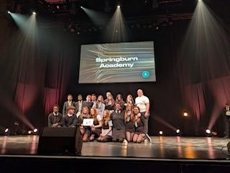
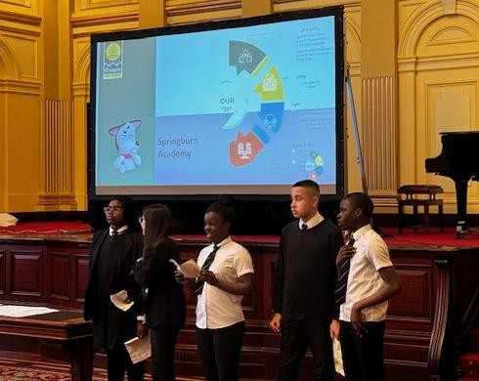


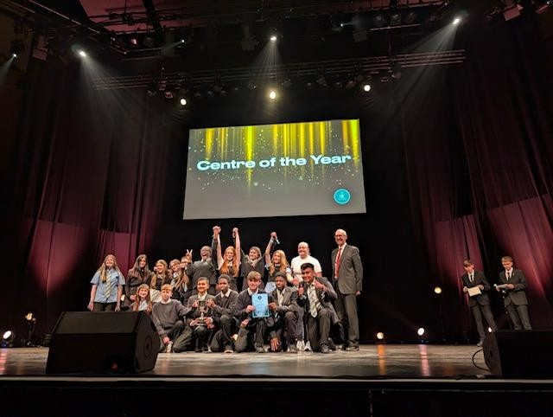
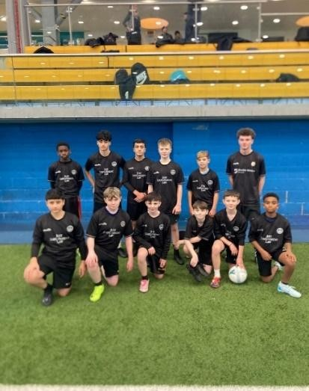
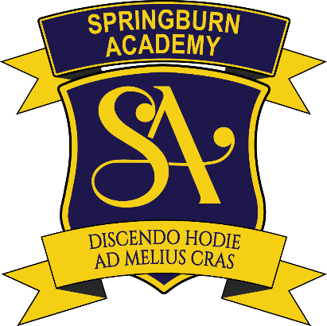

Springburn Academy

Person Specification
Principal Teacher of Modern Languages Springburn Academy
151 Edgefauld Road Glasgow
G21 4JL Phone: 0141 582 0230
Head Teacher: Letizia Riddell
Email: Headteacher@springburnacademy.glasgow.sch.uk

Our school vision

At Springburn Academy, we are proud to have worked in partnership with pupils, parents, staff, and our wider community through a consultation process that began in January 2025 and concluded in June 2025. Together, we created a new shared vision and values that will drive our school forward.
Our vision is ‘To provide a nurturing, excellent, and equitable learning environment where every young person is empowered to reach their full potential and supported into a positive and sustainable destination’ — captures our ambition for every learner. Underpinned by our values of Ambition, Respect, Kindness, and Honesty – this vision reflects the collective aspirations of our community and sets a clear direction for the future of our school.

We are now excited to bring this vision to life as we continue to strengthen our culture of ambition and care for everyone.

Our school values
Our school values of Ambition, Respect, Kindness and Honesty were chosen in partnership with our staff and pupils. They sit at the heart of our community and are central to supporting our shared school vision. By living these values every day, we bring our vision to life creating a nurturing, inclusive and aspirational environment that enables every young person to thrive.
Ambition: We aim high and encourage all our young people to dream big, work hard, and believe in their potential.
Respect: We treat everyone with dignity, value diversity, and promote a culture of mutual understanding. Kindness: We foster a caring and compassionate school community where every individual feels seen, safe, and supported.
Honesty: We act with integrity, take responsibility for our actions, and build trust through open communication.

School Information

Springburn Academy is a vibrant and diverse six-year comprehensive secondary school situated in the north of Glasgow. Our current school roll is 876 pupils and around 25% of our pupils have English as an additional language.

The school serves a broad catchment area that includes the communities of Springburn, Milton, Barmulloch, Royston, Petershill, Balornock, and Germiston. Our school community reflects the rich cultural and social diversity of the local area, and we are firmly committed to providing an inclusive, nurturing, and aspirational learning environment where every young person is supported to reach their full potential.

Springburn Academy is part of a wider Learning Community comprising seven associated primary schools: Barmulloch, Balornock, Chirnsyde, Elmvale, Miltonbank, Saracen, and Royston. The Learning Community meets regularly throughout the academic year to support effective transitions and promote collegiate working across sectors.

Our Staff
At the time of writing the Springburn Senior Leadership Team comprises of the Head Teacher supported by five Depute Head Teachers and an Operational Support Manager. It has an Extended Leadership Team of five pastoral Care Principal Teachers (PT), one Support for Learning Principal Teacher and fourteen curricular middle leaders. Through Pupil Equity Funding (PEF), the school appointed a Principal Teacher of Raising Attainment and Achievement in May 2025, alongside a Principal Teacher of Pupil Voice and a Principal Teacher of Family Learning and have been established to support strategic school improvement priorities from session 2025–2026 onwards. The school also benefits from a Developing the Young Workforce (DYW) Coordinator and PEF funded PT DYW, an MCR Pathways Coordinator, as well as six Support for Learning Workers who provide effective in-class support for learners. The total teaching complement is currently 61.7FTE.

Partners

There is a very supportive Parent Council that meets on a regular basis. The school also works with a number of partners to support pupils’ achievement e.g.: NG homes, DELL, Luddon Construction PLC, Strathclyde University’s Intergenerational Mentors, Mark Scott Leadership for Life, M.C.R. Pathways, Lifelink, Children’s University, Skills Development Scotland, Employability Skills, Outward Bound, Tron and St Mary’s Church, Glasgow Science Centre, Glasgow Kelvin College, John Muir, Duke of Edinburgh, Jessops, Educational Psychologist, Caledonian, Strathclyde and Glasgow Universities and Caledonian Hub for Advanced Highers.

Pastoral Care structure
All staff in Springburn Academy have a clear responsibility for the welfare and safeguarding of our young people.
At Springburn Academy, each year group is led by a Depute Head Teacher who takes on the role of Year Head. They are supported by a dedicated Pastoral Care Teacher who works closely with them to provide consistent support to our young people throughout their time in school.

This structure means that all pupils will have a continuous point of contact as they progress from S1 through to S6. The same Pastoral Care Teacher travels with the year group, allowing them to build strong, trusting relationships with both pupils and parents. This ensures personalised guidance, effective communication, and a supportive partnership between home and school.

Curriculum

Curriculum for Excellence has been introduced to raise standards of learning and teaching for all 3- to 18-year-olds. It aims to help prepare children and young people with the knowledge and skills they need in a fast-changing world. As part of Curriculum for Excellence, all children from pre-school to the end of S3 will receive a rounded education known as a Broad General Education (BGE). Curriculum for Excellence is all about bringing real life into the classroom and taking lessons beyond it.
We have recently introduced some curricular changes to our BGE curriculum which have been implemented from session 2025-2026, such as the inclusion of Drama and Geography within the curriculum. We have also increased the number of curricular subjects that pupils in S3 will study from 8 to 9, to ensure an appropriate breadth of learning experiences. During session 2025–2026, we have began a full curriculum review to ensure that our curriculum reflects national expectations and provides the best possible learning pathways for every young person. This review will support our ongoing commitment to excellence, equity, and continuous improvement, ensuring that all learners are well prepared for life, learning, and work.
In line with their Curriculum for Excellence entitlement, pupils should learn in all 8 curricular areas until the end of S3:

- Health & Wellbeing
- Languages
- Mathematics
- Sciences
- Social Studies
- Technologies
- Expressive Arts
- Religious & Moral Education

There is also a focus on developing literacy and numeracy skills across every subject area as well as Skills for Learning, Life and Work as young people prepare for their adult lives. In addition, learning takes place through Inter-disciplinary experiences (working across a range of subjects to link learning) and Learning through the ethos and life of the school.

Wider Achievement in the Senior Phase

As part of our ongoing commitment to providing a broad, balanced, and aspirational curriculum, Springburn Academy introduced a dedicated Wider Achievement period for all Senior Phase pupils from session 2025–2026 and from session 2026-2027 this will also feature in our S3.

This weekly period offers opportunities for young people to gain or work towards additional qualifications and awards at SCQF Levels 4 to 6, helping them to enhance their personal development, grow their skills for life and work, and maximise both attainment and achievement.

By broadening our curriculum offer in this way, we aim to recognise the full range of talents and strengths our learners bring, ensuring that every pupil leaves school with a strong, well-rounded portfolio of skills and qualifications.

Extra-Curricular Activities

In Springburn Academy we know that friendships that last a lifetime are born on the football field, rehearsing for the school show or celebrating achievements together.
We are proud to provide a variety of extra-curricular opportunities after school. There are also other opportunities for personal achievement through participating in school trips, excursions and events.
In PE we have a wide range of opportunities. For examples this year, many of our pupils have taken part in the following activities:

  - Duke of Edinburgh
  - Duathlon activities
  - Football Academy
  - Sports Development Award

Principal Teacher of Modern Languages

We are seeking a dynamic and talented full time Principal Teacher of Modern Languages (French & Spanish) to lead our committed team. At Springburn Academy, we believe our young people deserve the very best, and we are looking for a leader who shares that ambition. The successful candidate will demonstrate high aspirations for all learners and a strong commitment to both excellence and equity, ensuring that every young person experiences high-quality learning in French and Spanish. They will be a key team player in leading meaningful change, with the vision and drive to raise attainment, strengthen learning and teaching, and build a modern languages curriculum that is engaging, relevant, and inspiring. A passion for languages and their place in the wider world will be central to their work, alongside a clear focus on improving outcomes for all learners. As a middle leader, they will work collaboratively across the school, contributing to our wider improvement agenda and helping to ensure that all young people are supported to achieve their full potential.

Person Specification: Principal Teacher

Reports to | Head Teacher
Reference Number | As Advert
Grade | PT5
Hours | 35 Hours
Status | Permanent
Location | Springburn Academy
Closing Date | As advertised
Interview Date | TBC

Duties and Responsibilities of Principal Teachers

Key Area | General responsibilities and duties
Team Leadership | Responsibility for the leadership, good management and strategic direction of a team of staff responsible for supporting the learning within the department of Modern Languages.
Teaching and learning  Partnership Working | Responsibility to plan, deliver and assess high quality learning experiences for young people to raise attainment and achievement.  Responsibility for leading the development and delivery of a curricular programme suitable to meet the needs of all pupils, as dictated by the School Improvement Plan and Authority direction.  Promote partnership working with professional and support staff, parents/carers and appropriate agencies.
Quality Assurance and School Improvement | Contribute to the development, promotion and implementation of the school and department’s arrangements for self-evaluation and overall improvement.  Responsible for implementation of policies as a middle leader.
Contribution to Positive School Ethos | Contribute to and promote the development of a positive school ethos.  Contribute to and promote the development, promotion and implementation of school and department policy  and procedures.
Implementation of Pupil Support Strategies | Contribute to the development, promotion of, and implementation of school policy and procedures in relation to arrangements for supporting pupils.

Any other duties as directed by the Headteacher. In addition, principal teachers also have the duties and responsibilities of every teacher and a duty to carry out other such tasks and responsibilities
as designated by the headteacher within the terms of reference of Annex B of A Teaching Profession for the 21st Century.

Person Specification: Principal Teacher

Key Area | Essential | Desirable
Qualifications | GTC registration (Secondary) in relevant subject (French and/or Spanish) | Additional qualifications or professional learning relevant to leadership or Modern Languages
Experience & Leadership | Demonstrable experience of high-quality learning and teaching across secondary stages. Evidence of leading or contributing to departmental or whole-school improvement. Ability to inspire, motivate and support colleagues. Commitment to  continuous improvement and change | Experience of leading curriculum development in Modern Languages (French and/or Spanish). Experience of leading a team or managing change. Experience of contributing to whole-school initiatives
Learning, Teaching & Curriculum | Strong understanding of effective pedagogy to raise attainment and engagement.  Ability to lead high-quality learning and teaching in French and Spanish.  Commitment to delivering an inclusive and ambitious curriculum across BGE and Senior  Phase | Experience of developing innovative and engaging approaches to language learning. Experience of promoting languages and their relevance beyond the classroom
Raising Attainment & Achievement | Clear commitment to raising attainment and improving outcomes for all learners.  Ability to use data effectively to monitor, track and improve progress.  Experience of identifying and addressing gaps in attainment | Evidence of successfully improving attainment within a department or faculty. Experience of using data to inform targeted interventions
Supporting Learners | Commitment to inclusive practice and meeting the needs of all learners.  Experience of supporting young people with additional support needs.  Ability to promote positive relationships and a nurturing learning environment | Experience of working with partners and families to support young people.  Professional learning in areas such as nurture, trauma-informed practice or restorative approaches
Quality Assurance & Improvement | Commitment to self-evaluation and continuous improvement.  Experience of engaging in quality assurance processes to improve outcomes.  Ability to contribute to school improvement priorities | Experience of leading self-evaluation or quality assurance processes.  Experience of contributing to staff development and professional learning
Working Together | Strong interpersonal and communication skills. Ability to work collaboratively with colleagues, pupils, parents/carers and partners.  Commitment to contributing to a positive school ethos | Experience of leading partnerships or engaging with the wider community. Experience of presenting or leading professional learning

Glasgow City Council Education Services City Chambers (East) 40 John Street Glasgow G1 1JL

0141 276 9914
www.glasgow.gov.uk

