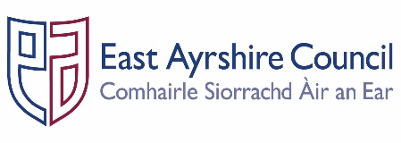
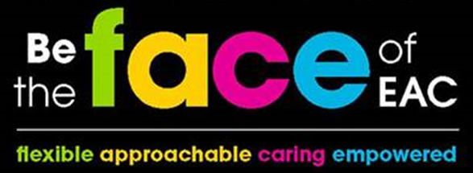
Job Outline

Post: Cook

Service: Health & Social Care Partnership

Section: Corporate Parenting

Grade: B
Job Purpose: Assist with the delivery of a high quality residential service for children and young people by preparing and serving a nutritional meal plan in a safe and clean environment in order to assist with the promotion, delivery and integration of the key objectives relation to those identified within the Health and Social Care Partnership Plan and the Community Plan.

- STRUCTURE CHART
House Manager

Cook

- KEY DUTIES & RESPONSIBILITIES

- Plan, prepare and serve a range of nutritionally balanced meals within the allocated budget in collaboration with the Residential Workers, Children and Young People.

- Ensure the safe and proper use of equipment, used in the preparation of food and related activities and assist with cleaning activities within the kitchen and dining area in accordance with COSHH (Control of Substances Hazardous to Health) guidance and current legislation.

- Adhere to the Council’s Child Protection procedures to support and protect Children and Young People in the care of the Partnership.

- Work as part of the team within the Children’s House, liaising with colleagues to ensure as homely a setting as possible for the Children and Young People in the care of the Partnership.

- Plan a nutritious seven day menu in conjunction with the Residential Workers, Children and Young People ensuring the menu meets the dietary needs of young people.

- Compile and purchase a list of ingredients in line with the agreed budget ensuring all stock is stored in accordance with the food hygiene standards.

- Prepare and store a range of ingredients suitable for the provision of nutritious meals.

- Prepare and serve a range of meals ensuring there is a minimum of two main meal choices.

- Ensure all food preparation equipment is used safely, cleaned and stored securely in accordance with the manufacturer guidelines and current health and safety regulations.

- Ensure all food preparation work surfaces and floor area are kept clean and all waste bins emptied daily in accordance with food hygiene standards.

- Ensure a range of administrative tasks are completed as required in relation to the remit of the work including maintaining food temperature reports.

- Report any issues or repairs to the House Manager or Duty Senior Residential Worker.

- Comply with all Service procedures on procurement, purchase ordering and stock control systems of equipment and consumables required to undertake the role.

- Report any incidents involving Child Protection and/or Health & Safety in respect of residents, employees and visitors to the House Manager or Duty Senior Residential Worker, who will record them within the appropriate system.

- Actively participate in the Health & Social Care Partnerships Supervision Policy.

- GENERAL RESPONSIBILITIES

- Ensure that any materials and equipment provided to assist in carrying out the duties of the post are properly secured in accordance with the Council’s policies and procedures.

- Ensure that the Council’s Customer Service Commitment is followed in all dealings with the people we serve

- Ensure all activities for which the post holder is responsible are delivered in accordance with Council’s Equality and Diversity Policies and the statutory and general specific Equality Duties.

- Promote the health and safety of employees at work and of service users through the implementation of the Council’s policy on health, safety and welfare at work and Service Health and Safety arrangements in accordance with all relevant statutory requirements, leading by example.

- Participate in the East Ayrshire FACE Time process annually in accordance with the Council’s procedures.

Person Specification
Designation: Cook | Post No:
Service: H & SCP | Section: Corporate Parenting

Attributes: | Essential Criteria | Desirable
Qualifications | - Elementary Food Hygiene Certificate (Royal Environmental Health Institute for Scotland) | - National Certificate in Food Preparation or equivalent.  - REHIS Intermediate Food Hygiene
Knowledge & Skills | - Demonstrate knowledge of cooking techniques.  - Ability to work to deadlines. i.e. food service times.  - Good literacy and numeracy skills  - Able to communicate with children and young people in a warm and friendly manner. | - Knowledge of COSSH Guidance and safe methods of work.  - Ability to build good positive working relationships with colleagues and young people.  - Able to recognise and assist with sensitive situations.
Experience | - Prepared meals within an educational or commercial environment.  - Planning and preparation of menus.  - Managed a small budget within a home or work environment | - Experience of working in an environment involving vulnerable young people, including those with additional care needs.  - Experienced or managed challenging behaviour.
Employees are the FACE of East Ayrshire and are expected to demonstrate our FACE qualities and behaviours
Quality | Behaviour
Flexible | - Have an open mind and look for better ways of doing things.  - Embrace new technologies to improve services for the people we serve.  - Welcome opportunities to learn and grow.
Approachable | - Develop positive and productive relationships with everyone.  - Listen, notice, respond and engage.  - Manage our reactions and think about how our behaviour affects others.
Caring | - Embrace working in a team and working with others.  - Take pride in your role, serving our community and strive to be the best we can be.  - Be kind to others and to ourselves.
Empowered | - Have the courage to try new things.  - Work with others to find the best solutions.  - Help everyone to realise their full potential.

