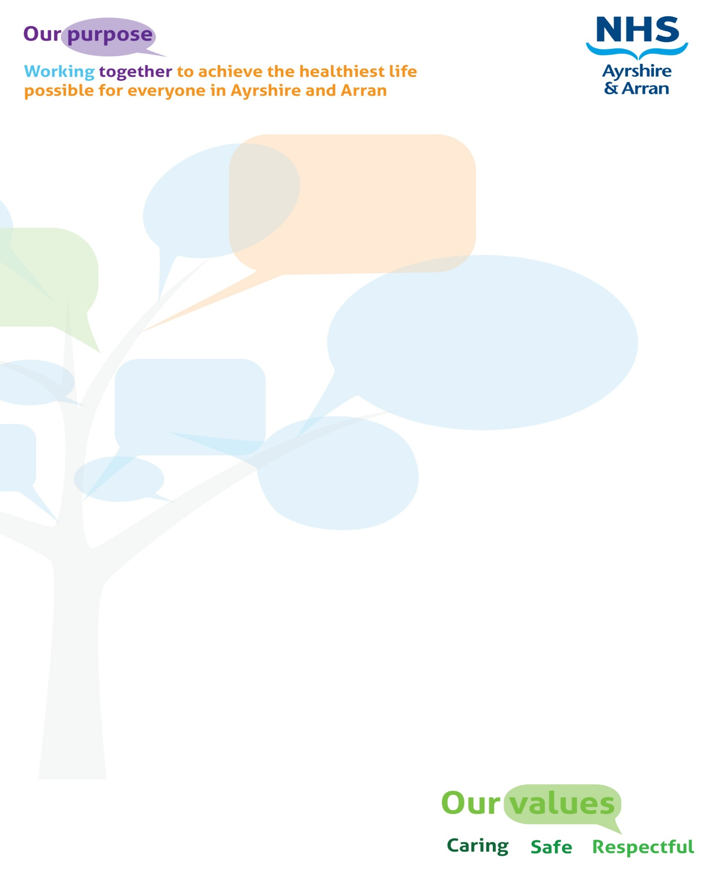
JOB DESCRIPTION TEMPLATE

JOB IDENTIFICATION
Job Title: Business Support Assistant (Social Care Team)

Responsible to: Business Support Admin Assistant / Business Support Officer

Department(s): East Ayrshire Health and Social Care Partnership

Directorate Business Support

Operating Division: Administration

Job Reference: EAC 1a / NHS 800-2403

No of Job Holders:

Last Update (insert date): January 2022

2. JOB PURPOSE
The post holder will provide a professional clerical support service to health and social care operational teams. Delivering this support in a friendly and efficient manner will be vital to the smooth operation of the teams.

The role of the post holder within the team is instrumental in ensuring the flow of communication, from a variety of sources projecting a positive, professional image for the whole function and in particular when acting as first point of contact for the Service.

To be the first point of contact for patients and visitors / callers to the Service, ensuring that all enquiries are dealt with promptly and efficiently, providing a positive image, ensuring confidentiality is maintained at all times and adhere to all organisational policies and procedures.

The post holder will be required to work flexibly to cover staff absences, and any periods of particular pressure.

3. DIMENSIONS
The post holder will ensure the delivery of a high quality clerical support service across a variety of teams within the Partnership.

The post holder will play a pivotal role within the Business Support Administration service supporting the wider operational teams across the Service.

Post holder will provide an agreed administrative support service to the wider operational teams based across various teams.

The post holder does not have staff line management, supervisory or budget responsibilities.

4. ORGANISATIONAL POSITION
Senior Manager
(Business Support)
Service Manager
(Business Support)

Senior Business Support
Officer

Business Support
Officer

Business Support
Admin Assistant
Business Support
Assistant

Business Support
Assistant

Business Support
Clerical Assistant

Business Support
Office Assistant

Supporting the following service areas
Justice
Services
AHP
Services
Mental Health, Alcohol and Drugs and Learning Disability Services
Planning, Performance and Information Governance
Children’s Health and
Care Services
Public Protection and
Learning & Development
Community Health and Care Services

5. ROLE OF DEPARTMENT
On 2 April 2015, East Ayrshire Integration Joint Board was established with the commitment to improving the health and care outcomes for patients, families and carers and wider communities within the East Ayrshire area.

NHS Ayrshire and Arran and East Ayrshire Council are working together, through the Integration Joint Board, as a Health and Social Care Partnership. The Partnership’s vision is to deliver positive outcomes for East Ayrshire residents by ensuring that children and young people get the best start in life, that people live healthier, longer lives and are supported to be independent and have choice and control - no matter who they are or where they live.

The Business Support Administration Service sits within the wider Business Support function of the Partnership, providing support to a wide range of NHS and Local Authority services and functions as per the structural diagram above.

The Business Support Administration Service provides a proactive, proficient and professional Business Support function and is responsible for effective administrative systems to ensure effective support to meet the needs of the Partnership and services therein. The Business Support Administration service is responsible for providing a first point of contact for the public in relation to Partnership Health and Social Care Services both in person and through ICT and / telephony contacts.

The Business Support Administration service is responsible for providing effective premises management support across all NHS East Ayrshire Health and Social Care Partnership community buildings and key East Ayrshire Council Health and Social Care Partnership buildings including overseeing the implementation of NHS and East Ayrshire Council Health, Safety and Wellbeing Policies and Procedures.

6. KEY RESULT AREAS
- Provide a point of contact and day-to-day clerical support for operational and clinical teams within the Partnership, ensuring the principles of good customer care are observed at all times.
- Receive and respond to general telephone and face to face enquiries from a wide range of sources, including but not restricted to, GPs, Health staff, Social Care staff, service users / patients, relatives, carers and service providers which frequently contain sensitive information and regularly contain emotionally disturbing issues.
- Have the ability to demonstrate an understanding of the services provided by East Ayrshire Council Health and Social Care Partnership and have the ability to liaise effectively and build relations with a range of stakeholders.
- Respond to general reception enquiries and process as directed, liaising with internal and external partners as appropriate. Ensure visitors are welcomed and directed to the correct meeting venue timeously and monitor reception waiting areas to avoid lengthy waiting times.
- Entering, filing, retrieving and maintaining data from a range of electronic and manual systems, maintaining confidentiality and sensitivity at all times.
- Ensure all operational systems are processed timeously and accurately to assist colleagues to carry out all procedures relevant to the efficient operation of the service.
- Word process correspondence independently and as directed in an accurate and orderly form and within agreed standards and timescales. Correspondence includes minutes, reports, referral forms, using both clinical and social work systems.
- Provide note taking support for a range of non-complex meetings.
- Undertake printing, copying and scanning of documents and upload to electronic information systems as required.
- Process incoming and outgoing mail – sorting, circulating and redirecting as appropriate.
- Be flexible in approach to service provision, as required within the Partnership.
- Undertake financial duties including the operation of PECOS, an electronic purchasing system, including generating purchase orders in accordance with procurement procedures and the Partnership’s Financial Regulations.
- Contribute to the development of information systems ensuring information recorded on manual and electronic systems used by the Partnership is accurate, up-to-date and maintained in accordance with the requirements of the Service and the Data Protection Act 2018.
- Ensure electronic filing systems adhere to Caldicott guidelines and the General Data Protection Regulation (GDPR) and Data Protection Act 2018, ensuring that confidentiality of medical and social care records are strictly adhered to.
- Adhere to the designated policies and procedures for good records management across the Service, ensuring that the correct information is created, maintained, stored and retrieved in accordance with business need and statutory and legislative requirements.
- Ensure all materials and equipment provided to assist in carrying out the duties of the post are properly secured in accordance with designated policies and procedures.
- Promote the health and safety of employees at work and of service users / patients through the implementation of health, safety and welfare at work policies and in accordance with all relevant statutory requirements, leading by example.
- Ensure that all activities for which the post holder is responsible are delivered in accordance with East Ayrshire Council and / or NHS Equality and Diversity Policy and the statutory and general and specific Equality Duties.
- Ensure all business activities are provided within a Best Value and quality framework and that performance is regularly monitored and continuous improvement achieved.
- Ensure that the Council’s Customer First Service Commitment and NHS Patient Charter is followed in all dealings with the people we serve.
- Ensure the Council’s Vision and NHS Values and wider corporate objectives, policies and procedures are considered and applied appropriately.
- Participate in the East Ayrshire FACE Time / NHS TURAS process annually in accordance with the Council’s / NHS procedures.
- The post holder is required to make decisions and judgements based on knowledge and experience, using discretion and confidentiality ie prioritisation of activities, mail, telephone calls, emails - analysing issues, determining possible solutions within agreed parameters and knowing when to ask for assistance or guidance.
- The main duties listed are not exhaustive and the post holder would be expected to make reasonable and appropriate adjustments in negotiation with the Service Manager.

7a. EQUIPMENT AND MACHINERY
The post holder is expected to have a safe working knowledge of all equipment, machinery and systems used within the establishment. Examples of equipment and machinery used are:-

- Digital Transcribing Equipment;
- Email and intranet;
- Laminator;
- Microsoft Office software;
- Multifunctional Device;
- Overhead Projector;
- Personal computer / printer;
- Telephone (landline).
- Telephone (mobile).

7b. SYSTEMS
The post holder requires a working knowledge and awareness of electronic systems record key data on behalf of the team.

The post holder will be required to access data sourced from service led information systems including, but not exclusive to:

- Care Partner;
- CHRIS 21 / SSTS;
- EMIS web / EMIS Community;
- Liquidlogic;
- Microsoft Packages
- Microsoft Teams;
- SCI Gateway;
- Symphony;
- Trakcare / PMS.

8. ASSIGNMENT AND REVIEW OF WORK
- The workload is demand led and monitored by the Business Support Admin Assistant / Business Support Officer. The post holder will prioritise their own workload and operate autonomously while carrying out day to day tasks accordingly to the needs of the service.
- The Business Support Admin Assistant / Business Support Officer is available for consultation on any non-routine issues, providing periodic supervision, as well as regular Team Meetings.
- Some duties are self-generated by the post holder for example filing / archiving and some are laid down by procedure / policy.
- The Business Support Team Admin Assistant / Business Support Officer carries out performance reviews for this post on a regular basis, with a formal PDR carried out on an annual basis.
- The job holder works with minimal supervision, with special instructions / advice / guidance being available from the Business Support Officer.

9. DECISIONS AND JUDGEMENTS
- The post holder is required to make decisions and judgements based on knowledge and experience, using discretion and confidentiality ie prioritisation of activities, mail, telephone calls, emails - determining possible solutions within agreed parameters and knowing when to ask for assistance or guidance.

- Receive telephone call or email, assess whether the post holder can deal with the issue personally taking into account policies and procedures and own operational parameters, or refer the issue to an appropriate individual using own knowledge and experience of the department.

- The post holder will use knowledge of systems and environment to make decisions required when carrying out duties.

10. MOST CHALLENGING / DIFFICULT PARTS OF THE JOB
- Building good communication links with internal teams/departments and external agencies
- Managing time effectively, prioritising work to meet competing demands.
- Frequent interruptions while carrying out duties which require a high level of concentration
- Working within an open plan environment.

- Periods of high levels of telephone calls / patients and visitors to reception.

- Dealing with telephone calls from distressed / anxious people who may display unpredictable behaviour.

11. COMMUNICATIONS AND RELATIONSHIPS
Strong interpersonal and communication skills are essential to assist in ensuring an inclusive and integrated planning process to meet specified objectives. The ability to establish and maintain effective communications with a wide range of people is paramount. The post holder utilises all communication media in engaging with the following individuals and groups:

Internal | External
- Colleagues within East Ayrshire Health and Social Care Partnership  - Health Professionals  - Other staff groups  - Support staff within NHS / EAC. | - Private Sector Organisations  - Service users / Patients / Carers and Relatives  - Staff within Local Authorities  - Staff within other Health Board areas  - Voluntary Organisations

12. PHYSICAL, MENTAL, EMOTIONAL AND ENVIRONMENTAL DEMANDS OF THE JOB
Physical (skills) :
- Keyboard – advanced keyboard skills, high degree of accuracy.

Physical (demands) :
- High proportion of work is computer based (90%) therefore sitting at a workstation for periods in line with DSE requirement.
- Being in sitting position (90%).

Mental (demands):
- Frequent concentration required when taking referrals, dealing with enquires;
- Frequent interruptions by telephone, email notification and staff;
- Retention and communication of information;
- Concentration to take notes of meetings;
- Must be able to meet tight deadlines and work under pressure;
- Unpredictable work pattern.

Emotional (demands) :
- Exposure to sensitive confidential information;
- Ability to work accurately under pressure;
- Exposure to circumstances when dealing with referral content that can at times be distressing.

Working Conditions :
- Almost continuous use of personal computer / laptop / thin client.
- Working within a busy open plan area.
- Some posts will work on a blended basis (rota for working from home / office based).

13. KNOWLEDGE, TRAINING AND EXPERIENCE REQUIRED TO DO THE JOB
- SVQ2 in Business / Administration or equivalent;
- Working experience of Health and / or Social Care environment;
- Used and maintained management information systems (MIS) including databases and spread sheets;
- Familiar with Microsoft Office systems;
- Provided a range of clerical supports including word processing, photocopying, filing and diary management;
- Excellent communication and interpersonal skills – both written and verbal;
- Experience of working within an NHS or Social Care Administration environment;
- A good attention to detail when producing / processing information;
- Demonstrate an understanding of the services provided by the Partnership;
- Able to liaise effectively and build relations with a range of stakeholders;
- Good organisational and time management skills;
- Ability to work on own initiative;
- Ability to work to deadlines.
- Experience of note taking would be desirable;
- Good time management skills.

14. JOB DESCRIPTION AGREEMENT
A separate job description will need to be signed off by each post holder to whom the job description applies.  Job Holder’s Signature:  Head of Department Signature: | Date:  Date:


Person Specification

Qualifications & Training – Essential Criteria
- SVQ Level 2 Business / Admin or equivalent qualification or equivalent demonstrable experience.

Qualifications & Training – Desirable Criteria
Experience – Essential Criteria
- Working experience of Health and / or Social Care environment;
- Used and maintained management information systems (MIS) including databases and spread sheets;
- Demonstrate and understanding of the services provided by East Ayrshire Health and Social Care Partnership;
- Used Microsoft Office applications including Word, Excel, Access, PowerPoint and Outlook;
- Provided a range of clerical supports including word processing, photocopying, filing and diary management.

Experience – Desirable Criteria
- Experience of note taking of meetings;
- Knowledge and working experience of operating systems – Liquidlogic, EMIS, PMS.

Knowledge – Essential Criteria
- Have a knowledge of Health and Safety requirements within an office environment.

Knowledge – Desirable Criteria
- Knowledge of Partnership policies and procedures.

Competencies & Skills – Essential Criteria
- Able to liaise effectively and build relations with a range of stakeholders;
- Good organisational and time management skills;
- Ability to interpret, prepare and present information;
- Ability to work on own initiative;
- Good telephone manner and have the ability to communicate with empathy and sensitivity;
- Ability to prioritise work and meet identified deadlines.

Competencies & Skills – Desirable Criteria

Personal Characteristics and Other – Essential Criteria
- A good attention to detail when producing / processing information;
- Good interpersonal skills;
- Enthusiastic and self-motivated;
- Prioritises workload and operates autonomously while carrying out day to day tasks;
- Methodical approach;
- Ensures all communication is clear, accurate, concise and easy to understand and avoids the use of jargon.

Personal Characteristics and Other – Desirable Criteria

