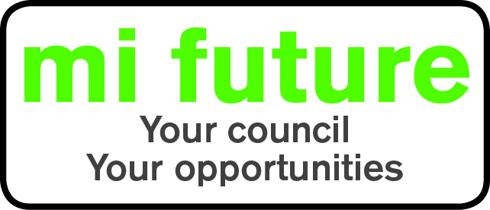

Generic Role Profile Strengths - Pro (4)

Midlothian Council has adopted a behavioural style of interviewing. Our interviews are structured and are strengths based, that is we search for a number of characteristics or skills, that we have identified as being important for success in the role in question.

Below are the strengths identified for the post you are applying for:-

Strengths for Matching

Persuasive - Is comfortable negotiating and likes to influence other people’s views.

Outspoken – Freely expresses opinions, makes disagreement clear and is prepared to challenge others, rather than holding back.

Data Rational - Likes working with numbers, enjoys analysing statistical information.

Evaluative - Evaluates information, identifying potential limitations or errors.

Detail Conscious – Focuses on detail, liking to be methodical organised and systematic.

Achieving –Ambitious and career centred, likes to work to demanding goals and targets.

