InverclY,de
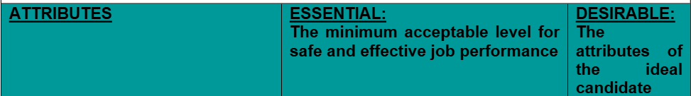
council

The Person Specification clearly describes the skills/abilities/personal qualities needed to successfully undertake the duties of the post. It is agreed by the Panel prior to advertising and is used as the sole means of selecting candidates for interview.
In developing job descriptions & person specifications, the Council will have due regard to its commitment to equality & diversity by ensuring that job criteria are relevant to the successful undertaking of the job and do not indirectly or disproportionately disadvantage any individual on the grounds of sex, age, disability, race/ethnic origin, religion or belief, sexual orientation, gender reassignment, marriage and civil partnership, pregnancy and maternity and caring responsibilities or social status, unless it can be justified on objective rounds
POST TITLE: Systems Co-ordinator

ATTAINMENTS/EXPERIENCE  1.Educational  (e.g. qualifications, membership of  professional bodies) | HND or comparable in relevant discipline or equivalent demonstrable  experience. | Supervisory experience
2.Occupational  (e.g. management experience) | Detailed knowledge and skills in operation of a range of mapping software and their applications, e.g. Cadcorp/ Esri Arc GIS.  Detailed knowledge and skills in operation of IDOX product suite (including Uniform, DMS, Public Access, enterprise, etc.). | Understanding of planning and Building Standards procedures related to application registration, validation and  determination processes.
 | Detailed knowledge and skills in operation of MS Office suite/ M365.  Train and develop staff to use systems and technologies that support the work of the Service | Knowledge of security and administration of IT systems.

Invercl�£t�
SKILLS & ABILITIES  (e.g. work ethic, motivation, judgement, initiative, analytical skills, problem solving skills, report writing skills) | Highly motivated.  Able to work on own initiative and as part of a team.  Take responsibility for own workload, identifying priorities and meeting deadlines.  Excellent communication skills such as presenting information and responding to enquiries.  Excellent problem-solving skills.  Excellent presentational skills and ability to present information clearly and concisely.  Experience and knowledge of handling and maintaining data sets, mapping information and analysis. | Experience in digital solutions and innovation  report writing skills  Experienced in representing a Council or organisation at events associated with the role and  responsibilities e.g., planning and building standards digital stakeholder events
SPECIAL APTITUDES  (e.g. numerical skills, manual dexterity, driving licence) | Experience of leading on project delivery, service improvements and initiatives.  High level digital skills to develop and integrate different digital systems including coding and module reformatting.  Understand business systems and be able to manage change of systems to ensure ongoing service delivery and continuous improvement.  Ability to extract, manipulate and interpret data using systems.  Understand the importance of confidentiality and data protection/ GDPR. | Full driving licence or the ability to travel to locations across Inverclyde and also add travel to any industry events and training opportunities out with Inverclyde
ANY ADDITIONAL JOB RELATED  REQUIREMENTS (e.g. ability to |  | Able to work flexibly.
work irregular hours, shifts


Date produced: July 2026

Under the 'Disability Confident' scheme, an applicant who indicates they have a disability and who meet the essential requirements for the vacancy will be offered a guaranteed interview.

