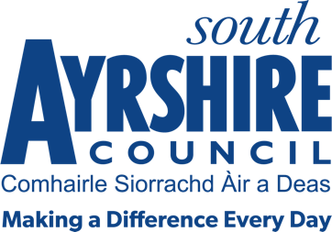




Job Purpose

To assist the facility supervisor in the preparation of facilities to the highest standard for use by the public.

Date: 29/9/21
Job Title Lifeguard/Leisure Attendant

Level 4

Service Sports & Leisure

Job Description

Post Responsibilities:
- Apply and adhere to council policies and procedures, including assisting in Pool Water testing where required.
- Ensure adherence to relevant legislation, external policy and safe practices.
- An awareness and application of customer service standards..
- Ensure information and advice is communicated in a clear, concise and accurate manner through written and verbal communication.
- Ability to meet targets in accordance with set timescales.
- Supervise users of the centre and the activities taking part therein.
- Cleaning of facilities.
- Prepare facilities for use including setting up and dismantling of equipment, furniture, etc
- Receive fees and issue tickets as appropriate.
- Control and security of facilities including changing facilities and toilets.
- Where applicable give trained assistance to leisure service users.

Possession of:
- RLSS National Pool Lifeguard Award.
- It will be the responsibility of the post holder to maintain as valid, the minimum qualifications for the post at all times during the period of employment.
- A current first aid qualification is desirable.
- An awareness of Health & Safety in the workplace and moving and handling training desirable.

Substantiated ability to:
- Work as an individual but also part of a team.
- Be responsive to the needs and demands of customers.
- Be flexible in respect of the workload delivery.
- Meet the standards of performance required under the Values and Behaviours of South Ayrshire Council.

Demonstrable experience of:
- Using initiative with personal drive and a flexible approach.
- The ability to remain calm and accurate under pressure.
- Working within a leisure centre/swimming pool environment and evidence in providing excellent customer service desirable.

In terms of the Protection of Vulnerable Groups (Scotland) Act 2007, this post is designated as
Regulated Work. Consequently, in order to undertake the duties of this post, you must hold
Membership of the Protecting Vulnerable Groups (PVG) Scheme.

If you are charged with any offence, or are involved in any activity which may have implications
For your membership of the PVG Scheme, you must immediately notify your Line Manager.

