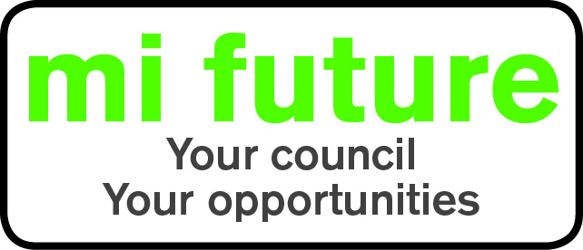

Generic Role Profile Strengths – AS1

Midlothian Council has adopted a behavioural style of interviewing. Our interviews are structured and are strengths based, that is we search for a number of characteristics or skills, that we have identified as being important for success in the role in question.
Below are the strengths identified for the post you are applying for:-
Strengths for Matching

Adaptable – Changes behaviour to fit the situation or behaves differently depending on who they are with.

Socially Confident - Feels comfortable when first meeting people and is at ease in formal settings.

Conventional - Prefers established methods and traditional approaches.

Vigorous – Thrives on activity, and enjoys having a lot to do.

Detail Conscious - Focuses on detail, liking to be methodical organised and systematic.

