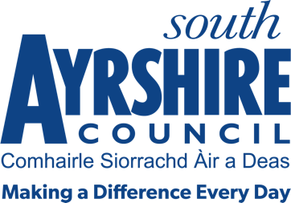



Job Title Paralegal (Public Law)

Level 7

Service Legal and Licensing

Job Purpose

To assist in the delivery of a professional legal support service in accordance with Council policies, relevant legislation and best practice.

Date: June 2026

Job Description

Post Responsibilities:
- To accept and check instructions from client departments to raise court actions, including housing eviction actions, former tenant arrears, and other debt recovery actions.

- To carry out all administrative work involved in the raising of conjoined actions and simple procedure actions, including preparing Summary Cause summonses and obtaining warrants for service, ensuring proper service including, where necessary, instructing Sheriff Officers and preparing court lists.

- To carry out all administrative work involved in recalling court actions which are sisted at court including preparing Incidental Applications, obtaining Interlocutors and ensuring proper service including, where necessary, instructing Sheriff Officers.

- To carry out all administrative work involved in raising court actions for former rent arrears, and other debt recovery matters, including preparing simple procedure claim forms, ensuring proper service including, where necessary, instructing Sheriff Officers.

- To prepare and send out letters as requested by Housing, or other client services, prior to raising court actions

- To obtain instructions from relevant council staff prior to courts and prepare a detailed court list for solicitors attending court, collating all information which may be necessary.

- To deal with routine business.

- To liaise with instructing client departments and ensure that they are kept informed as to the progress and outcomes of cases, and deal with any queries which are raised.

- To carry out diligence for recovery of arrears, or other debts owed to the Council, where requested, by the relevant client department, following decree being obtained at Court.

- To prepare reports on recovery of arrears.

- To serve summary applications in the statutory form and within statutory timescales, including guardianship actions in terms of the Adults with Incapacity Act (Scotland) 2000.

- To assist with preparations for elections, as may be required by required by the Legal Services Coordinator (Litigation), Service Lead - Legal and Licensing or the Chief Governance Officer, Legal and Regulatory Services

- To administer databases in relation to regulatory and statutory functions of the Council (e.g. RISPA and Adults with Incapacity cases).

- To carry out such other duties consistent with the post as may be required by the Legal Services Coordinator (Litigation), Service Lead - Legal and Licensing or the Chief Governance Officer, Legal and Regulatory Services.

Possession of:
- Candidates should have a recognised paralegal qualification in a relevant area (HNC or equivalent), or have appropriate relevant experience with the ability to undertake relevant paralegal qualification

Substantiated ability to:
- Deliver a high standard of service delivery.

- Resolve complex problems.
- Meet the standards required under the Values and Behaviours of South Ayrshire Council.

Demonstrable experience of:
- Meeting targets and working to deadlines.
- Interpreting, analysing and presenting complex data.
- Communication with a range of internal and external contacts using a range of channels.

Proven Technical Understanding of:
- Microsoft Office packages.

