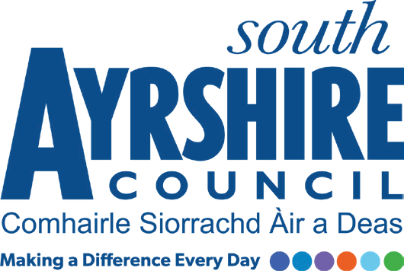



Job Title Licensing Support Supervisor

Level Level 7

Service Legal and Licensing

Job Purpose

Under the direction of the Coordinator (Licensing), assist in the provision of an efficient and effective support service for the Licensing Team by supervising the day-to-day organisation and operation of all general clerical/administration duties, and contributing to service planning, performance monitoring and focusing on outcomes for customers.

Date: May 2026

Job Description

Post Responsibilities:

- Processing civic government, liquor and gambling applications with a particular focus on large/significant events

- Supervise the clerical and administration team within Licensing by means of effective delegation of workload to meet deadlines and ensure compliance with all Council Policies and Procedures.

- Assist in the development of and day to day administration of effective information systems and practices and compile statistical and other management information.

- Undertake all employee related administration tasks including calculating annual leave, recording absence, processing timesheets, recording PDR’s, as well as maintaining all employee records associated with these tasks.
- Undertake a formal team supervisory role, directing and supervising day to day activities within a team including supervision of all types of licences prepared by the team, and forward planning and prioritising activities where appropriate.

- Allocate tasks and monitor the performance of team members.

- Assist in the recruitment process where applicable.

- Assist with the development and updating of office systems including Uniform, and ensure their implementation to effectively support the licensing service, and in line with changing legislation and technology, including online access to licensing applications.

- Assist with the preparation of responses to FOI and EIR requests for the service.

- Collect and monitor statistical information as required.

- Monitor and track customer enquiries, complaints, feedback and suggestions, assisting with directing enquiries to the correct person or team, assisting with responses and ensuring that these are dealt with in accordance with council policy and procedures

- Assist the Coordinator (Licensing) to devise systems to monitor the performance and quality of services

- Assist in the provision of information as required to other Council Departments and/or external bodies, including liaising and consulting with stakeholders as required

- Participate in on-going training as directed to meet the requirements of the post, maintain personal development and update skills.

Possession of:

- Knowledge of licensing legislation and/or a licensing paralegal qualification would be desirable
- HNC or SVQ Level 3 or educated to Higher level and / or be able to demonstrate relevant work experience this field.

Proven Record of:

- Experience of working in a demanding customer-oriented environment and ability to meet targets and deadlines;

- Work on own initiative and as part of a team;

- Manage and prioritise own workload with good organisational skills;

- Experience of data collection, validation and input.

Substantiated ability to:

- Meet the standards required under the Values and Behaviours of South Ayrshire Council;
- Understand the importance of confidentiality and data protection;
- Demonstrate excellent organisational and interpersonal skills with the ability to prioritise workloads and meet deadlines;

- Demonstrate effective written and verbal communication skills.

Demonstrable experience of:

- Excellent communication skills, both written and verbal with the ability to disseminate instructions to others;

- Self-motivation with the skills to motivate others, with a positive approach to team-work.

Proven Technical Understanding of:

- Computer systems with extensive knowledge of all Microsoft Office Packages.

