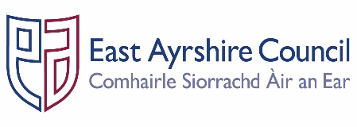
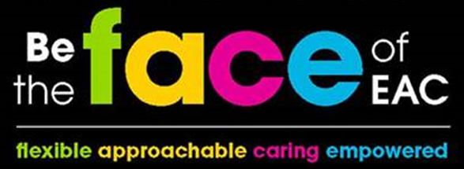

Job Outline

Post: | Modern Apprentice - Business Administration
Service: | Communities and Economy
Section: | Housing and Communities
Grade: | MA
Job Purpose: | To provide business support to services within the Council function to an agreed learning contract in order to assist with the promotion, delivery and integration of the Council’s key objectives; specifically in relation to the Community Plan, Shared Commitments, Single Outcome Agreement and Best Value.

A. | Structure Chart

Line Manager

Modern Apprentice

B. | Functional Responsibilities

- Respond to general enquiries and correspondence and process as directed, liaising with internal and external customers as appropriate.

- Provide photocopying, mail, fax, filing, call-handling, word processing and other related tasks as required.

- Participate in the Modern Apprentice Programme to ensure that training and employment needs are met.

- Receive visitors to the department ensuring principles of good Customer Care are observed at all times.

- Make and receive internal/external telephone calls, dealing with enquiries personally, or referring to the appropriate sources.

- Process all incoming and outgoing, internal and external mail, ensuring efficient distribution, appropriate recording and tracking procedures are followed.

- Maintain various records, registers and statistical information, both manual and computerised.

- Assist with the co-ordination of archiving and retention of records in accordance with the Data Protection Act.

- Operate PECOS, the council’s electronic purchasing system; including generating purchase orders in accordance with procurement procedures and entering delivery notes.

- Use Microsoft Office software (Word, Excel, Powerpoint and Email).

- Undertake a level 2 Business and Administration Modern Apprenticeship.

C. | General Responsibilities

- Ensure that any materials and equipment provided to assist in carrying out the duties of the post are
properly secured in accordance with the Council’s policies and procedures.

- Ensure that the Council’s Customer First Service Commitment is followed in all dealings with the customers and clients of the Service.

- Ensure that all activities for which the post holder is responsible are delivered in accordance with the Council`s Equal Opportunities Policy and its statutory and general and specific Equality Duties.

- Comply with all instructions relating to the health and safety of employees at work and of service users through the implementation of the Council’s policy on health, safety and welfare at work and departmental Health and Safety arrangements in accordance with all relevant statutory requirements.

- Participate in the East Ayrshire FACE Time review process in accordance with the Council’s procedures and participate in further training and learning opportunities as required within the post.

PERSON SPECIFICATION

Designation: Modern Apprentice – Business Admin
Service: Communities and Economy |  | Section: Housing and Communities
Attributes: | Essential Criteria | Desirable
Qualifications |  | - 3 National Qualifications at Level 5, one being in a Business/IT subject
Knowledge & Skills | - Able to take instruction and direction to assist in the completion of work.  - Able to work as part of a team and complete tasks with general levels of supervision.  - Be approachable and flexible  - Able to communicate with others | - Awareness of duties included within Admin role  - Knowledge of good customer care skills
Experience |  | - Experience of using ICT  - Experience of answering calls and enquiries.

Employees are the FACE of East Ayrshire and are expected to demonstrate our FACE qualities and behaviours

Quality | Behaviour
Flexible | - Have an open mind and look for better ways of doing things.  - Embrace new technologies to improve services for the people we serve.  - Welcome opportunities to learn and grow.
Approachable | - Develop positive and productive relationships with everyone.  - Listen, notice, respond and engage.  - Manage our reactions and think about how our behaviour affects others.
Caring | - Embrace working in a team and working with others.  - Take pride in your role, serving our community and strive to be the best we can be.  - Be kind to others and to ourselves.
Empowered | - Have the courage to try new things.  - Work with others to find the best solutions.  - Help everyone to realise their full potential.

