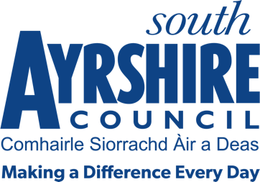



Job Title Communities Officer

Level 7

Service Adult Learning Disability Service

Job Purpose

Assist in the provision of a professional thematic service for one of the service priorities:

Further Educational Support
Community Learning and Development
Community Engagement
Volunteering and Work Placement

Date: 14th October 2026

Job Description

Post Responsibilities:
- Support the delivery of programmes through participating in a range of thematic projects and initiatives.
- Deliver programmes in relation to community services in geographical areas - for one of the service priorities: Volunteering & Skills, Educational Transitions, Community Engagement,
- Deliver programmes that meet the needs and contribute to local and national priorities.
- Manage caseloads, monitoring and tracking outcome.
- Provide direct line management.
- Maintain appropriate records including records of progression, training plans and report on progress and outcomes in appropriate formats to meet the needs of funding, regulatory and qualification bodies.
- Provide an assessment and verification service for a range of accredited qualifications.
- Support the moderation and verification process through verification activity, participating and chairing standardisation meetings or events as appropriate.
- Support effective Volunteering engagement.
- Work in collaboration with a range of agencies
- Evening and weekend work may be required on occasions.
- Assist with the Council, Directorate and Service Planning process.
- Contribute to service improvement at Directorate and Service levels.
- Assist with Council wide improvement initiatives.
- Ensure compliance with performance standards, council policies/procedures and corporate governance in line with organisational values.
- Deliver, promote and contribute to a positive working environment, with specific reference to the Council’s Vision and Values.
- Undertake duties in line with the Adult Learning Disability Strategy.
- Undertake any other duties as may be prescribed by the Lead Officer, Depute Unit Team Leader or other designated officer.

Possession of:
- Qualified to SCQF Level 6 or above in relevant qualification or appropriate level of experience in the relevant discipline.

Substantiated ability to:
- Meet the standards of performance required under the Values and Behaviors of South Ayrshire Council

Demonstrable experience of:
- Successfully supporting the achievement of outcomes across thematic services

In terms of the Protection of Vulnerable Groups (Scotland) Act 2007, this post is designated as
Regulated Work. Consequently, in order to undertake the duties of this post, you must hold
Membership of the Protecting Vulnerable Groups (PVG) Scheme.

If you are charged with any offence, or are involved in any activity which may have implications
For your membership of the PVG Scheme, you must immediately notify your Line Manager.

