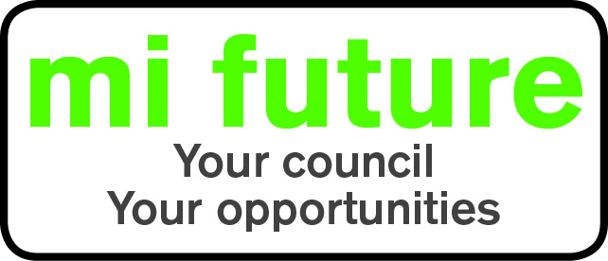

Generic Role Profile Strengths - OC (c)7

Midlothian Council has adopted a behavioural style of interviewing. Our interviews are structured and are strengths based, that is we search for a number of characteristics or skills, that we have identified as being important for success in the role in question.
Below are the strengths identified for the post you are applying for:-

Strengths for Matching

Controlling - Likes to be in charge, take the lead in stations and tell others what to do.

Adaptable – Changes behaviour to fit the situation or behaves differently depending on who they are with.

Persuasive – Is comfortable negotiating and likes to influence other people’s views.

Innovative – Enjoys generating new ideas, being creative, and thinks of original solutions

Evaluative - Evaluates information, identifying potential limitations or errors.

