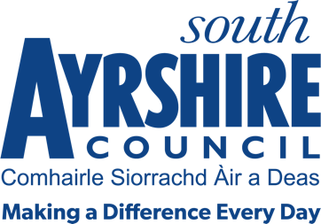




Job Purpose

Under the direction of the Co-ordinator (Education Administration) co-ordinate and support
the management of administration services within school and the wider learning community.

Date: 01 October 2026

Date:
Job Title Admin Team Leader (Schools Administration)

Level 11

Service Education

Job Description

Post Responsibilities:
- Assist Head Teacher in the line management of school clerical staff, librarians and technicians.
- Contribute to the wider development of administration services in Education.
- Assist with the development and maintenance of performance management systems which monitor the progress of key administrative functions such as pupil registration, pupil information transfers and ScotXed.
- Assist with the management, development and operation of ICT systems.
- Undertake a lead role in the co-ordination of the Check In process for all school support staff
- Contribute to the development, implementation and monitoring of agreed health and safety processes and procedures
- Undertake an advisory role in relation to administration services within the learning community
- Ensure adherence to relevant policies, procedures and legislation
- Under the direction of the Co-ordinator, lead a team in the delivery of effective administration services
- Contribute to service improvement through the development and implementation of consistent administration processes within learning communities to ensure best value and a customer focussed approach to service delivery.
- Contribute to the service and school management service planning process
- Carry out duties consistent with the post as may be required by your Line Manager

Possession of:
- HND or Degree in Administration or equivalent experience or have appropriate experience working at this level

Substantiated ability to:
- Demonstrate excellent written and verbal communication skills
- Demonstrate effective communication with a diverse range of people and groups
- Work on own initiative but also effectively as part of a team
- Be responsive to the needs and demands of customers
- Demonstrate good organisational skills and ability to manage own workload
- Flexibility in respect of workload delivery
- Meet the standards required under the Values and Behaviours of South Ayrshire Council

Demonstrable experience of:

- Leading a team
- Dealing with difficult and delicate situations
- Working in a demanding environment, meeting targets and deadlines

In terms of the Protection of Vulnerable Groups (Scotland) Act 2007, this post is designated as
Regulated Work. Consequently, in order to undertake the duties of this post, you must hold
Membership of the Protecting Vulnerable Groups (PVG) Scheme.

If you are charged with any offence, or are involved in any activity which may have implications
For your membership of the PVG Scheme, you must immediately notify your Line Manager.

