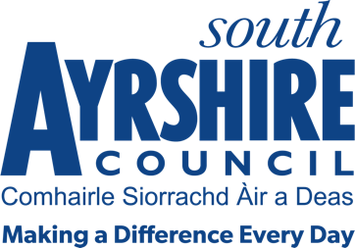




Job Purpose

To assist the Supervisor (Spaces & Places) in the preparation of facilities to the highest standard for use by the public.

Date: May 2022

Job Title Leisure Attendant

Level 4

Service Sports, Leisure & Golf

Job Description

Post Responsibilities:
- Supervise users of the Riverside Sports Arena and the activities taking part therein, and other facilities when necessary
- Ensure adherence to relevant legislation, external policy and safe practices
- Preparing/serving food & drinks as required
- An awareness and application of customer service standards.
- Ensure information and advice is communicated in a clear, concise and accurate manner through written and verbal communication
- Ability to meet targets in accordance with set timescales
- Cleaning of facilities
- Prepare facilities for use including setting up and dismantling of equipment, furniture, etc
- Receive fees and issue tickets as appropriate
- Control and security of facilities including changing facilities and toilets
- Where applicable give trained assistance to leisure service users
- Apply and adhere to council policies and procedures, including assisting in Pool Water testing where required
- Carry out duties consistent with the post as may be required by your Line Manager

Possession of:
- REHIS Elementary Food Hygiene or equivalent (or willingness to achieve prior to appointment)
- A current first aid qualification is desirable
- An awareness of Health & Safety in the workplace and moving and handling training desirable

Substantiated ability to:
- Work as an individual but also part of a team
- Be responsive to the needs and demands of customers
- Be flexible in respect of the workload delivery
- Meet the standards of performance required under the Values and Behaviours of South Ayrshire Council

Demonstrable experience of:
- Using initiative with personal drive and a flexible approach
- The ability to remain calm and accurate under pressure
- Working within a leisure centre/swimming pool environment and evidence in providing excellent customer service desirable

In terms of the Protection of Vulnerable Groups (Scotland) Act 2007, this post is designated as
Regulated Work. Consequently, in order to undertake the duties of this post, you must hold
Membership of the Protecting Vulnerable Groups (PVG) Scheme.

If you are charged with any offence, or are involved in any activity which may have implications
For your membership of the PVG Scheme, you must immediately notify your Line Manager.

