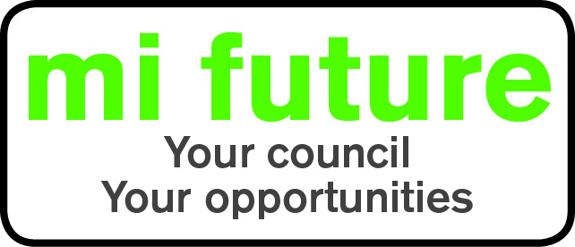

Generic Role Profile Strengths – C6

Midlothian Council has adopted a behavioural style of interviewing. Our interviews are structured and are strengths based, that is we search for a number of characteristics or skills, that we have identified as being important for success in the role in question.
Below are the strengths identified for the post you are applying for:-

Strengths for Matching

Caring – Tends to be sympathetic, considerate, helpful and supportive of others.

Relaxed –Finds it easy to relax, unwind after work and generally remain calm and untroubled.

Persuasive – Is comfortable negotiating and likes to influence other people’s views.

Evaluative – Evaluates information, identifying potential limitations or errors.

Innovative – Enjoys generating new ideas, being creative, and thinks of original solutions

Decisive –Reaches conclusions quickly and makes fast decisions.

Persuasive – Is comfortable negotiating and likes to influence other people’s views

Adaptable – Changes behaviour to fit the situation or behaves differently depending on who they are with.

