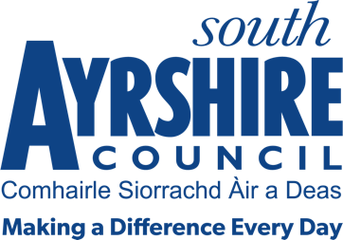



Job Title Senior Administrative Assistant (ATF/CA/Non-residential care)

Level 7

Service Revenues & Benefits

Job Purpose

To assist the Social Care Support Officer in the delivery of the Social Care Support (Finance) – Access to Funds (ATF), Corporate Appointees (CA) and Non Residential Care/billing administration activity in relation to the relevant client groups.

Date: 01 July 2023

Job Description

Post Responsibilities:

- To work in an efficient manner to meet performance targets and timescales that are contained in the SCS Service Team Plan wherever possible

- Assist in the collation of accurate financial information for use in the production of performance indicators, financial projections, Freedom of Information responses and other service-related returns.

- To ensure that all relevant data is processed completely, accurately, efficiently and in a timely manner through the Council’s Social Work, Financial & banking systems.

- To be responsible for the administration of the Corporate Appointee/Access to funds function including;

- Assisting with new CA/ATF application process
- Providing support to & liaising with Social Workers/Care Managers
- Maintaining agreed payment plans & adhoc payments for CA’s
- Reconciliation of CA bank accounts
- Dealing with Customer Enquires & complaints

- To assist with Non-residential care billing and assessment duties as required.
- To deputise for the Social Care Support Officer as and when appropriate.

- To assist the Social Care Support Officer with training of new staff within the team.

- Undertake other duties, commensurate with grade, as may be prescribed by the Service Lead – Revenue and Benefits.

Possession of:

HNC/SVQ Level 3 or equivalent in a recognised qualification, or appropriate relevant work experience.

Substantiated ability to:
- Work on own initiative and achieve deadlines.
- Work individually and as part of a team.
- Prioritise work and deliver results against agreed timescales
- Meet the standards of performance required under the values and behaviours of South Ayrshire Council.

Demonstrable experience of:

- Working within a public sector setting.
- Flexible approach to the discharge of duties.
- Excellent communication and interpersonal skills.
- Self-motivation and enthusiasm with the ability to motivate others whilst adapting to a positive approach to team work ethics.

Proven Technical Understanding of:

- Microsoft Office packages and Council Systems e.g. Civica Billing, Oracle Fusion, Carefirst

