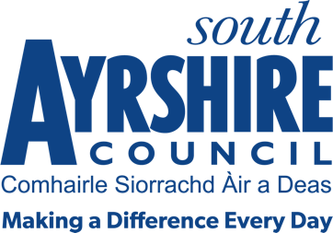



Job Title Senior Administrative Assistant (Residential care - Finance)

Level 7

Service Revenues & Benefits

Job Purpose

To assist the Social Care Support Officer in the delivery of the Social Care Support (Finance) – Residential Care financial assessment administrative activity in relation to relevant client groups.

Date: Sep 2024
Job Description

Service Specific Responsibilities:

- To work in an efficient manner to meet performance targets and timescales that are contained in the SCS Service Team Plan wherever possible

- To ensure that all relevant data is processed completely, accurately, efficiently and in a timely manner through the Council’s corporate financial ledger and Social Work systems;
- To be responsible for the administration of Residential Care financial assessment function in accordance with Charging for Residential Accommodation Guidance (CRAG) in relation to:

- Purchase order Processing and maintenance;
- Processing new care home admissions;
- Client financial assessments;
- Further funding applications;
- Dealing with client arrears;
- Customer and client queries/complaints.

- Assist in the collation of accurate financial information for use in the production of performance indicators, financial projections, Freedom of Information responses and other service-related returns.

- To deputise for the Social Care Support Officer as and when appropriate.

- To assist the Social Care Support Officer with training of new staff within the team.

- Undertake other duties, commensurate with grade, as may be prescribed by the Service Lead – Revenue and Benefits.

Possession of:

HNC/SVQ Level 3 or equivalent in a recognised qualification, or appropriate relevant work experience.

Substantiated ability to:
- Work on own initiative and achieve deadlines.
- Work individually and as part of a team.
- Prioritise work and deliver results against agreed timescales
- Meet the standards of performance required under the values and behaviours of South Ayrshire Council.

Demonstrable experience of:

- Working within a public sector setting.
- Flexible approach to the discharge of duties.
- Excellent communication and interpersonal skills.
- Self-motivation and enthusiasm with the ability to motivate others whilst adapting to a positive approach to team work ethics.

Proven Technical Understanding of:

- Microsoft Office packages and Council Systems e.g. Oracle Fusion, Carefirst, NEC Document Management

