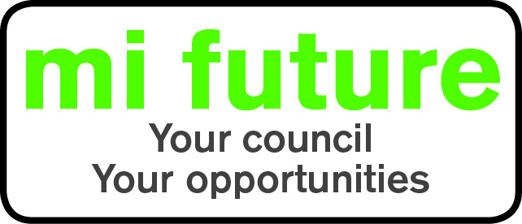

Generic Role Profile Strengths - OC (a)4

Midlothian Council has adopted a behavioural style of interviewing. Our interviews are structured and are strengths based, that is we search for a number of characteristics or skills, that we have identified as being important for success in the role in question.
Below are the strengths identified for the post you are applying for:-

Strengths for Matching

Detail Conscious – Focuses on detail, liking to be methodical organised and systematic.
Conscientious –Focuses on getting things finished and persists until the job is done.
Rule Following - Follows rules and regulations, prefers clear guidelines.
Evaluative - Evaluates information, identifying potential limitations or errors.
Independent minded – Likes To follow own approach, whilst being prepared to disregard majority decisions.
Vigorous – Thrives on activity, and enjoys having a lot to do.
Adaptable – Changes behaviour to fit the situation or behaves differently depending on who they are with.

