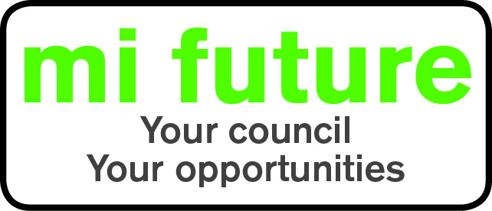

Generic Role Profile Strengths – C8

Midlothian Council has adopted a behavioural style of interviewing. Our interviews are structured and are strengths based, that is we search for a number of characteristics or skills, that we have identified as being important for success in the role in question.
Below are the strengths identified for the post you are applying for:-

Strengths for Matching

Controlling - Likes to be in charge, take the lead in stations and tell others what to do.
Independent minded – Likes To follow own approach, whilst being prepared to disregard majority decisions.
Democratic – Likes to consult and involve others, making sure everyone has a say before making a decision.
Decisive – Reaches conclusions quickly and makes fast decisions.
Forward Thinking – Prefers to take a long term view, setting goals for the future and takes a strategic perspective.
Persuasive - Is comfortable negotiating and likes to influence other people’s views.
Evaluative - Evaluates information, identifying potential limitations or errors.

