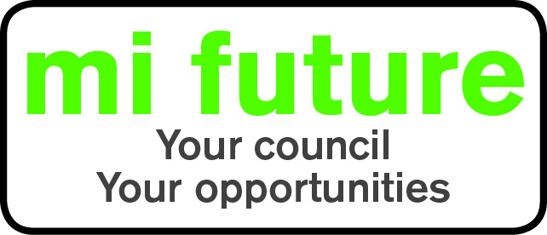

Generic Role Profile Strengths – PPT2

Midlothian Council has adopted a behavioural style of interviewing. Our interviews are structured and are strengths based, that is we search for a number of characteristics or skills, that we have identified as being important for success in the role in question.
Below are the strengths identified for the post you are applying for:-

Strengths for Matching

Persuasive – Is comfortable negotiating and likes to influence other people’s views.

Conceptual – Is interested in theories and enjoys discussing abstract concepts.

Controlling – Likes to be in charge, take the lead in stations and tell others what to do.

Adaptable – Changes behaviour to fit the situation or behaves differently depending on who they are with.

Evaluative – Evaluates information, identifying potential limitations or errors.

Innovative – Enjoys generating new ideas, being creative, and thinks of original solutions.

Vigorous – Thrives on activity, and enjoys having a lot to do.

Socially Confident - The degree to which a person feels comfortable or awkward when first meeting people and is at ease in formal settings.

