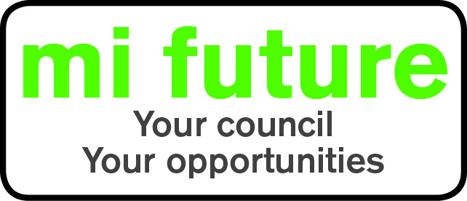

Generic Role Profile Strengths – AS2

Midlothian Council has adopted a behavioural style of interviewing. Our interviews are structured and are strengths based, that is we search for a number of characteristics or skills, that we have identified as being important for success in the role in question.

Below are the strengths identified for the post you are applying for:-

Strengths for Matching

Socially Confident - Feels comfortable when first meeting people and is at ease in formal settings.

Adaptable – Changes behaviour to fit the situation or behaves differently depending on who they are with.

Conventional - Prefers established methods and traditional approaches.

Vigorous – Thrives on activity, and enjoys having a lot to do.

Innovative – Enjoys generating new ideas, being creative, and thinks of original solutions.

Detail Conscious – Focuses on detail, liking to be methodical organised and systematic.

Conscientious –Focuses on getting things finished and persists until the job is done.

