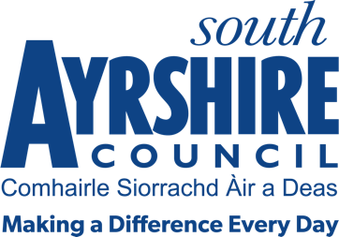




Job Purpose

To provide extended personal care to the most vulnerable members of the community, in a way that supports the maintenance of the individual’s independence and dignity and offers them a positive choice in their own home.

Date: 01 August 2020

Job Title Home Carer

Level 5

Service Health and Social Care Partnership

Job Description

Post Responsibilities:
- To support individuals in achieving their maximum independence in the context of a safe, supportive and homely environment through undertaking personal care and related tasks.
- Establish and maintain professional relationships with service users, families, carers and other professionals to promote outcome focused practice.
- To support the maintenance of appropriate records via an appropriate medium and operate electronic systems which support the service to deliver an efficient and effective service for their designated area.
- To provide intimate personal care to people including medical care where appropriate including support with prescribed medication in accordance with the South Ayrshire Council Medication Policy.
- To support healthy daily living and to promote assessed personal rehabilitation goals as agreed in the Joint South Ayrshire Council/Health Protocol and in a way that complies with the Council’s Health & Safety risk assessments.
- To liaise with the Supervisor (Care at Home) and other staff, on any changes to the physical or mental well-being of respective individuals in receipt of a home care service for the maintenance of their individual Personal Plan.
- To participate in on-going training as directed for the maintenance and development of relevant skills for the proper delivery of the duties of a Home Carer.

Possession of:
- Candidates should have or be working towards an SVQ level 2 in Social Care or equivalent with the ability to attain appropriate qualifications to meet current and future registration requirements.
- Valid UK driving licence

Substantiated ability to:
- Proven ability of being responsive to the needs and demands of customers.
- Must have initiative, personal drive and be flexible.
- Ability to work to tight timescales and remain calm under pressure.
- Ability to promote independence in appropriate aspects of daily living.
- Applicants will be expected to travel efficiently and effectively between various work locations.
- Genuine empathy and concern for vulnerable people and the ability to adapt communication skills as appropriate to the person with previous knowledge/experience of providing personal care.
- Applicant must be able to recognise and report concerns about the well-being of children and vulnerable people and be able to maintain appropriate professional relationships with people in receipt of a service and their family.
- Meet the standards required under the Values and Behaviours of South Ayrshire Council.

Demonstrable experience of:
- Must be able to demonstrate an ability to work on own initiative but also part of a team.
- Knowledge of First Aid and Moving & Handling are desirable.
- An awareness of Health & Safety in the workplace
- Must be able to demonstrate a high level of discretion.

In terms of the Protection of Vulnerable Groups (Scotland) Act 2007, this post is designated as Regulated Work. Consequently, in order to undertake the duties of this post, you must hold Membership of the Protecting Vulnerable Groups (PVG) Scheme.

If you are charged with any offence or are involved in any activity which may have implications for your membership of the PVG Scheme, you must immediately notify your Line Manager.

