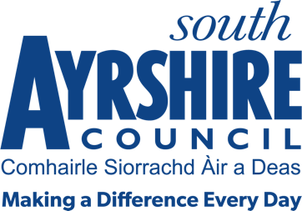



Job Title Communities Assistant

Level 5

Service Thriving Communities

Job Purpose

Under the direction of the Senior Communities Officer, develop and deliver thematic programmes for one of the service priorities in a variety of locations in South Ayrshire:

Employability & Skills
Community Learning and Development
Community Safety
Community Engagement
Health and Wellbeing

Date: April 2021

Job Description

Post Responsibilities:
- Assist with the delivery of the thematic service through participating in a range of projects and initiatives
- Support the delivery of a range of training and development interventions, ensuring all accredited training is delivered to appropriate standard in relation to funding, regulatory and qualification bodies
- Attend moderation, verification, progress or standardisation meetings or events as appropriate.
- Prepare, deliver, monitor and evaluate programmes
- Provide appropriate information advice and guidance
- Record outcomes and achievements
- Implement appropriate procedures, including those that relate to accredited learning
- Maintain appropriate records and produce reports as necessary
- Work with a range of partners and agencies
- Monitor and maintain inventory of learning resources
- Evening and weekend work may be required on occasions
- Apply and adhere to council policies and procedures
- Adhere to relevant legislation, external policy and safe practices
- Continually monitor and evaluate practices to ensure quality service provision and service improvement.
- Contribute to service improvement to ensure a best value, customer focused approach to service delivery.
- Responsible for ensuring information and advice is communicated in a clear, concise and accurate manner through written and verbal communication.
- Undertake any other duties as may be prescribed by the Senior Communities Officer or other designated officer.

Possession of:
- SVQ level 2 or equivalent
- Good organisational skills with the ability to manage own workload

Substantiated ability to:
- Deliver a range of programmes in the following disciplines: Employability, CLD, Community Safety, Community Engagement and Health and Wellbeing
- Communicate with clients, colleagues, partners and external agencies.
- Work on own initiative, also a part of a team.
- Meet the standards required under the Values and Behaviours of South Ayrshire Council.

Demonstrable experience of:
- Experience in delivering programmes in a thematic area is essential.
- Working with young people or adults with the ability to demonstrate high quality, well-practiced groupwork skills in a local authority setting is desirable.
- A knowledge of importance of improving life chances through lifelong learning

In terms of the Protection of Vulnerable Groups (Scotland) Act 2007, this post is designated as
Regulated Work. Consequently, in order to undertake the duties of this post, you must hold
Membership of the Protecting Vulnerable Groups (PVG) Scheme.

If you are charged with any offence, or are involved in any activity which may have implications
For your membership of the PVG Scheme, you must immediately notify your Line Manager.

