School Profile
Woodland View School

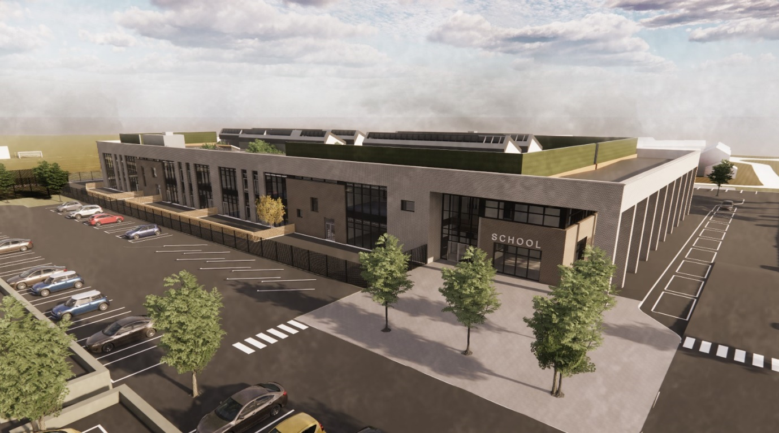

East Dunbartonshire Council

Woodland View School - East Dunbartonshire Council

Woodland View School opened in August 2023 as a purpose built, standalone ASN provision for East Dunbartonshire Council. The school is a non-denominational, co-educational school for learners with additional support needs within the local authority whose learning needs are of a complexity that they require a specialist, standalone educational provision. The school provides an adapted environment and specialist teaching for children and young people of nursery, primary and secondary age. The placement of each learner is regularly reviewed to ensure the school remains the most appropriate learning environment for the child or young person, within the wide range of supports which are available within the authority.
Woodland View School is a merger of the existing EDC provisions for learners who required this high level of support – Merkland School and Campsie View School and Nursery. The school design was architect-led by a team who have a range of experience in this area, supported by the staff, parent and learner teams of each school.
As the school has grown we have continued to adapt within our environment to ensure the needs of all the children and young people are being met.

Accommodation and Facilities

Woodland View is an incredible, purpose built provision incorporating a range of facilities and design features which continue to highlight the value that East Dunbartonshire Council place on the education of children and young people with additional support needs. The two-storey building is located in a site to the east of the local authority, but serves children and young people from across East Dunbartonshire Council. The classrooms are designed in clusters, based on the specific needs of each group of learners, with many classrooms having access to the beautiful outdoor areas around the school.
The pupils have access to high specification teaching spaces for both the broad general education and senior phase learning, and practical classrooms e.g. Home economics, art etc., will ensure a breadth and depth of learning is accessible to all. Facilities such as a hydrotherapy pool and sensory space continue to support the physical, social and emotional needs of the children and young people.

School Staffing

School staff from both Merkland and Campsie View Schools came together in the new school, and have been joined by a number of newly appointed staff. In addition to the teaching and support staff, there are janitorial and dining staff, and health and well-being workers. There are a number of visiting professionals who are involved in supporting our learners, including nursing staff, speech and language therapists, physiotherapists and occupational therapists. All staffing is based on the needs of individuals and their classes – all interventions are bespoke to the child.

Curriculum

Curriculum for Excellence is fully embedded in the school. Where appropriate, each pupil may have individual targets set in addition to their planned learning experiences, which address their barriers to learning and support them in successfully accessing the curriculum. In the senior phase our young people achieve within the full range of National Qualifications, as well as wider achievement awards including ASDAN, Duke of Edinburgh, Youth Achievement Awards etc.

Parental Involvement

We have both a parent council and a parent teacher association which is attended by parents/carers and staff as well as representatives from the local authority and elected members. Our PTA has newly formed and is planning a range of exciting events for the benefit of the school community.

Further Information
Further information on the school can be found on the EDC website.

