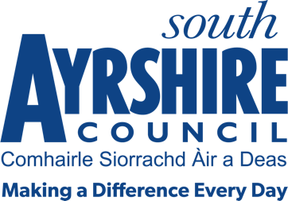



Job Title Sports Development Assistant (Active Schools)

Level 5

Service Health and Wellbeing

Job Purpose

Under the direction of the Active Schools Manager and Head Teachers, work alongside Active Schools Co-ordinators to promote healthy lifestyles, tackle health inequalities, increase the range of physical activities in the target areas, and to increase participation in local club and community opportunities.

Date: 01 June 2021

Job Description

Post Responsibilities:

- To develop and support pupils to take part in school sport opportunities through the Active Schools programme.

- To support pupils to take part in competitive sporting opportunities through the competitive School Sport calendar.

- Develop links with club and community opportunities, supporting pupils to attend.

- Continually monitor and evaluate practices to ensure impact on target groups.

- Identify sporting pathways and support necessary for talented children.

- Assist with the supervision and development of a range of extra-curricular programmes within schools and communities.

- Work with the HWB team to promote and support opportunities to take part in competitive sporting opportunities.

- Assist in the development of programmes to help deliver the aims of the attainment challenge within targeted local communities.

- Assist with the preparation of reports relating to the Active Schools Programme, compile and maintain evidence of impact, registers and records.

- Work with parents and carers to support children in engaging with sport and physical activity within a school and community setting.

- Carry out associated administrative duties.

- Evening and weekend work.

Possession of:

- SVQ level 3, HNC or equivalent experience.

Substantiated ability to:

- Work in a demanding environment, meeting targets and deadlines.
- Meet the standards required under the Values and Behaviours of South Ayrshire Council.

Demonstrable experience of:

- Must have experience of working with children in education, sport, health and leisure or recreation industry.

- Working with key community partners.

- Physical activity and sport planning.

In terms of the Protection of Vulnerable Groups (Scotland) Act 2007, this post is designated as
Regulated Work. Consequently, in order to undertake the duties of this post, you must hold
Membership of the Protecting Vulnerable Groups (PVG) Scheme.

If you are charged with any offence, or are involved in any activity which may have implications
For your membership of the PVG Scheme, you must immediately notify your Line Manager.

Applicants must be able to recognise and report concerns about the wellbeing of children and vulnerable service users and be able to maintain appropriate professional relationships with service users.

Must be able to travel efficiently and effectively between various locations.

