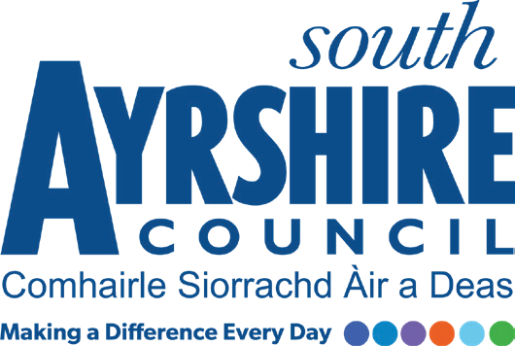




Job Purpose

To undertake duties connected with the removal of domestic, commercial and industrial refuse from all types of locations by working as part of a team to carry out waste collection. Assisting the driver in the safe manoeuvring of the vehicle on collection routes and at disposal points.
To undertake duties involving, recycling, street cleaning and other waste management operations.

Date:
Job Title Refuse Loader

Level Grade 1, Level 4

Service Neighbourhood Services (Waste Management)

Job Description

Post Responsibilities:

- Uplift of all types of domestic, commercial and industrial waste, leaf clearance, litter collection and control including dog fouling, routine maintenance and cleaning.

- Removal of sharps and illegally deposited waste.

- To operate hydraulic lifting equipment on a variety of waste collection vehicles using where necessary mechanical aids.

- Completion of any associated paperwork as required.

- Participate in the implementation of effective operational plans to meet the objectives of the service.

- Assist in meeting appropriate operational and other statutory targets.

- Work with limited supervision to Foreperson/ Team Leader’s instructions to deliver quality standards required under Environmental Protection Act.

- Contribute to a positive and inclusive working environment within which regular performance review takes place and undertake further training as appropriate.

- Ensure safe working practices in line with Health & Safety policy, Risk Assessments and Safe Systems of Work.

- To be aware of and adhere to the council’s Code of Conduct at all times.

- To be responsible for ensuring information and advice is communicated in a clear, concise and accurate manner through written and verbal communication.

- To carry out such other duties consistent with the post as may be required by the Foreperson, Team Leader, Service Co-ordinator and Service Lead - Neighbourhood Services including commencing work from another depot and undertaking duties with other departments within Neighbourhood Services if and when required or instructed.

Possession of:
- Good level of physical fitness.
- Good health and mobility.
- Knowledge of Health and Safety working practices in relation to Waste Management Operations.

Substantiated ability to:
- Identify and separate waste streams as presented for collection.
- Ability to work as team member or a lone worker as required and to accept responsibility for the direction of the work of trainees and/or other employees assigned to them when required.
- Ability to meet targets in accordance with set timescales.
- To adapt within a flexible working environment.
- Meet the standards required under the Values and Behaviours of South Ayrshire Council.

Demonstrable experience of:
- Manual handling.
- Communicating effectively with colleagues and members of the public.
- Working with limited supervision to Foreperson/Team Leader’s instructions to deliver quality standards required under EPA.
- Working in all weather conditions.

