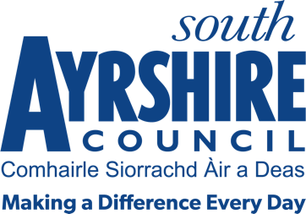




Job Purpose
To assist in the effective operation of council buildings and their visitors including security, maintenance, caretaking & cleaning.

Date: October 2021
Job Title Janitor

Level Level 3

Service Facilities Management

Job Description

Post Responsibilities:

- Carry out minor repair and maintenance to ensure the general upkeep of building and grounds.

- Ensure adequate stock of approved cleaning materials.

- Cleaning of designated areas as required.

- Responsible for security and welfare to all staff, pupils and visitors.

- To assist with the efficient utilisation of equipment, transport and materials.

- To liaise with external contractors as and when required.

- Supervision of council building to prevent damage, interference with property, unauthorised entry and parking.

- Complete log of any occurrences within the premises ie vandalism.

- Maintain safe pedestrian access to the premises.

- Undertake duties concerned with the safe passage of school children, including the control and direction of traffic at school crossing areas when required

- To carry out such other duties consistent with the post as directed by the Facilities Team Leader.

Possession of:

- Basic knowledge and awareness of Health and Safety Working practices

- Basic IT skills using Word and Excel

- Basic problem solving skills

- General Road Safety awareness

- Ability to work either as a team member or lone worker, as required

- Good health, mobility and physical fitness

Substantiated ability to:

- Demonstrate relevant work experience relative to the role

- Maintain accurate records including H&S register/logs

- Be proactive with the ability to prioritise work, deliver results and achieve deadlines

- Self-motivate with the skills to motivate others, with a positive approach to team work

- Articulate with good manners and a willingness to help others

- Work with limited supervision to deliver quality standards

- Meet the standards required under the Values and Behaviours of South Ayrshire Council

Demonstrable experience of:

- Facilities management and an understanding of premises requirements

- Manual Handling skills and experience

- Excellent Communication skills

- Working and adapting within a flexible working environment with the ability to cover various locations across South Ayrshire Council as and when required including weekend

- Customer care

In terms of the Protection of Vulnerable Groups (Scotland) Act 2007, this post is designated as
Regulated Work. Consequently, in order to undertake the duties of this post, you must hold
Membership of the Protecting Vulnerable Groups (PVG) Scheme.

If you are charged with any offence, or are involved in any activity which may have implications
For your membership of the PVG Scheme, you must immediately notify your Line Manager.

