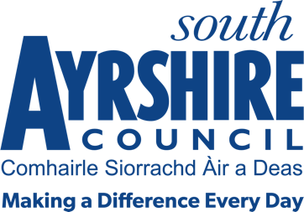




Job Purpose

To undertake, under the general direction of the Café Supervisor the preparation and serving of food and drinks.

Date: April 2019
Job Title Café Assistant

Level 2

Service Golf and Community Facilities

Job Description

Post Responsibilities:
- Preparation of food and beverages
- Simple cooking
- Transporting and serving of meals
- Till duties and cash handling
- General kitchen and Café duties
- Cleaning of the kitchen, the Café area and equipment
- Provide a service that is customer focused.
- To carry out other duties consistent with the post as directed by the Café Supervisor or the Belleisle Visitor Liaison Officer.

Possession of:
- Basic knowledge and awareness of Health and Safety Working practices
- Ability to work either as a team member or lone worker, as required
- Good health, mobility and physical fitness

Substantiated ability to:
- Demonstrate relevant work experience relative to the role
- Articulate with good manners and a willingness to help others
- Work with limited supervision to deliver quality standards
- Comply with and understand the importance of adhering to the dress code relevant to the role, reflecting public image in conjunction with service delivery
- Work within a flexible working environment including working weekends
- Meet the standards required under the Values and Behaviours of South Ayrshire Council

Demonstrable experience of:
- Food preparation within a café environment
- Manual Handling skills and experience
- Good communication skills with the ability to follow instructions.
- Self-motivation, reliability, and enthusiasm

Proven Technical Understanding of:
- Customer care with a strong commitment to providing a high standard of service delivery.
- Literacy and numeracy
- Health and Safety Practices relative to the post

