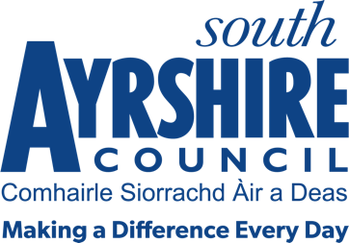



Job Title Communities Officer

Level 7

Service Thriving Communities

Job Purpose

Assist in the provision of a professional thematic service for one of the service priorities:

Employability & Skills
Community Learning and Development
Community Safety
Community Engagement
Health and Wellbeing

Date: 15 June 2021

Job Description

Post Responsibilities:
- Support the delivery of programmes through participating in a range of thematic projects and initiatives.
- Deliver programmes in relation to community services in geographical areas - for one of the service priorities: Employability & Skills, Community Learning and Development, Community Safety, Community Engagement, Health and Wellbeing
- Deliver programmes that meet the needs and contribute to local and national priorities.
- Manage caseloads, monitoring and tracking outcomes to support ongoing development.
- Provide a range of training and development interventions, ensuring all accredited training is delivered to appropriate standards in relation to funding, regulatory and qualification bodies.
- Maintain appropriate records including records of progression, training plans and report on progress and outcomes in appropriate formats to meet the needs of funding, regulatory and qualification bodies.
- Provide an assessment and verification service for a range of accredited qualifications.
- Support the moderation and verification process through verification activity, participating and chairing standardisation meetings or events as appropriate.
- Support effective employer engagement.
- Work in collaboration with a range of agencies
- Evening and weekend work may be required on occasions.
- Assist with the Council, Directorate and Service Planning process.
- Contribute to service improvement at Directorate and Service levels.
- Assist with Council wide improvement initiatives.
- Ensure compliance with performance standards, council policies/procedures and corporate governance in line with organisational values.
- Deliver, promote and contribute to a positive working environment, with specific reference to the Council’s Vision and Values, Employee Deal and South Ayrshire Way.
- Undertake any other duties as may be prescribed by the Senior Communities Officer, Communities Team Leader or other designated officer.

Possession of:
- Qualified to SCQF Level 6 or above in relevant qualification or appropriate level of experience in the relevant discipline.

Substantiated ability to:
- Meet the standards of performance required under the Values and Behaviors of South Ayrshire Council

Demonstrable experience of:
- Successfully supporting the achievement of outcomes across thematic services

In terms of the Protection of Vulnerable Groups (Scotland) Act 2007, this post is designated as
Regulated Work. Consequently, in order to undertake the duties of this post, you must hold
Membership of the Protecting Vulnerable Groups (PVG) Scheme.

If you are charged with any offence, or are involved in any activity which may have implications
For your membership of the PVG Scheme, you must immediately notify your Line Manager.

