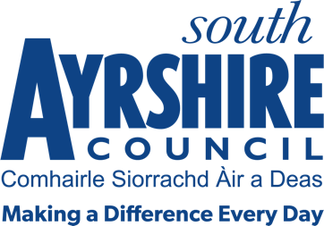




Job Purpose
Under the direction of the Instructor and Officer, assist in the delivery of high quality sports instructional programmes (Aquatics and/or Gymnastics) across South Ayrshire Sport & Leisure facilities.

Date: 23/3/22
Job Title Assistant Instructor (Aquatics/Gymnastics)

Level 3

Service Destination South Ayrshire

Job Description

Post Responsibilities:

- Apply and adhere to council policies and procedures
- Ensure adherence to relevant legislation, external policy and safe practices
- Under the supervision of the relevant Instructor and Officer monitor and evaluate practices to ensure quality service provision and service improvement
- Contribute to service improvement to ensure a best value, customer focussed approach to service delivery
- Ensure information and advice is communicated in a clear, concise and accurate manner through written and verbal communication
- As part of a team, assist in providing continuity of coaching throughout a sports coaching term/course
- Assist the relevant Instructor in the delivery of the sports programmes according to the guidelines and standards set
- Assist the relevant Instructor in the development and promotion of appropriate Council sports programmes and awards schemes
- Assist the relevant Instructor in lesson plans to ensure delivery standards meet the needs of the individual participant

Maintain qualifications in line with the National Governing Bodies continued professional development policy
- Carry out duties consistent with the post as may be required by your Line Manager.

Possession of:

- Level 1 Gymnastics (general or pre-school) and/or Scottish Swimming Teaching Qualification (SSTQ) or working towards the relevant qualification

Substantiated ability to:

- Ability to work evenings and weekends as required

- Ability to travel between locations

- Good communication skills

- Meet the standards required under the Values and Behaviours of South Ayrshire Council

Demonstrable experience of:

- Coaching/Sports Leadership

In terms of the Protection of Vulnerable Groups (Scotland) Act 2007, this post is designated as
Regulated Work. Consequently, in order to undertake the duties of this post, you must hold
Membership of the Protecting Vulnerable Groups (PVG) Scheme.

If you are charged with any offence, or are involved in any activity which may have implications
For your membership of the PVG Scheme, you must immediately notify your Line Manager.

Applicants must be able to recognise and report concerns about the wellbeing of children and vulnerable service users and be able to maintain appropriate professional relationships with service users.

