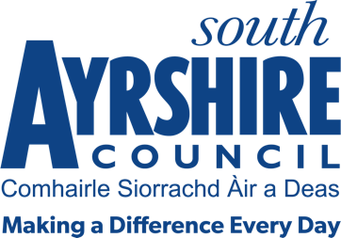




Job Purpose

To support the Assistant in Charge in the provision of an efficient and effective library service.

Date: January 2022
Job Title Library Assistant

Level 3

Service Destination South Ayrshire – Tourism, Events and Culture

Job Description

Post Responsibilities:

- To apply and adhere to council policies and procedures.
- Ensure adherence to relevant legislation, external policy and safe practices.
- Ensure information is communicated in a clear, concise and accurate manner.
- An ability to work on your own also operate as an effective member of a team.
- Ability to meet targets in accordance with set timescales.
- Issue and return books and other items for library users by means of the library’s computerised management system.
- Return books and other items to the correct location on library shelves.
- Use the library’s computerised management system to access information about books and other items held by the library.
- Offer assistance to library users to find books and/or information.
- Use printed and electronic sources to answer information enquiries from users.
- Electronic till operation and cash handling.
- Undertake the safe and effective operation of library equipment: computers, printers, tills, photocopiers, fax machines and microfilm reader/printers.
- Carry out simple book repairs.
- Participate in library promotional events and activities.

Possession of:
- SVQ Level 2 or equivalent qualification or relevant work experience.
- ECDL or be willing to undertake training.
- An awareness of Health and Safety in the workplace is desirable.

Substantiated ability to:
- Be flexible in respect of the workload delivery.
- Meet the standards required under the Values and Behaviours of South Ayrshire Council.

Demonstrable experience of:
- Experience of using PC’s and the internet.
- Excellent written and verbal communication skills.
- Working on own initiative but also as part of a team.
- Being responsive to the needs and demands of customers.
- Working with the public and with dealing with difficult and delicate situations.
- Good organisational skills with the ability to manage your own workload.

In terms of the Protection of Vulnerable Groups (Scotland) Act 2007, this post is designated as Regulated Work. Consequently, in order to undertake the duties of this post, you must hold Membership of the Protecting Vulnerable Groups (PVG) Scheme.

If you are charged with any offence, or are involved in any activity which may have implications For your membership of the PVG Scheme, you must immediately notify your Line Manage.

