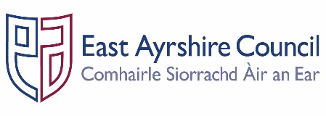
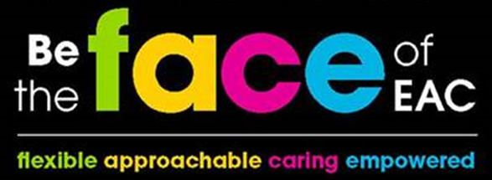

JOB OUTLINE

Post: Quantity Surveyor

Service: Communities & Economy – Facilities & Property Management

Section: Asset Investment – Quantity Surveying

Grade: G10
Job Purpose:

Under supervision of line manager to form an integral part of a team within the Surveying Section of a multi-disciplinary professional Design Services Unit, providing a full range of surveying services in relation to those identified within the Facilities & Property Management Plan and the Community Plan.

- SECTION STRUCTURE CHART

Strategic Lead – Asset Investment

Project Planning & Resource Manager

Senior Quantity Surveyor

- KEY DUTIES & RESPONSIBILITIES

- Form an integral part of a team within the Quantity Surveying Section of a multi-disciplinary professional Design Services Unit, supporting Senior Managers in providing a full range of quantity surveying services, required for the delivery of the Council’s property related capital and major maintenance programmes, as well as providing technical support on property related matters.

- Assume responsibility in respect of projects allocated, for providing a comprehensive high quality service from inception to completion, as well as assisting Senior Managers in a team environment on individual projects.

- Carry out pre-contract quantity surveying duties including preliminary estimates, cost planning, preparation of bills of quantities and description of works.

- Carry out post contract quantity surveying duties including interim valuation, cost reporting & analysis and settlement of final measurement.

- Order and pay for works to be instructed under framework or measured term contracts, on a schedule of rates basis.

- Handle all aspects of projects funded in part by external agencies.

- Develop close working relationships with other colleagues within Corporate Infrastructure, together with Officers in other Council Departments/Services.

- Contribute to developing a constructive atmosphere within the working environment in which staff at all levels accepts their responsibility for quality assurance and customer satisfaction.

- To ensure that he/she and the employees and/or any outside bodies under his/her control complies with the Council’s and Departments Health and Safety at Work procedures and other relevant legislation and to ensure that safe systems of work are used at all times.

- Carry out such other tasks from time to time as may be allocated to the post.

- GENERAL RESPONSIBILITIES

- Ensure that any materials and equipment provided to assist in carrying out the duties of the post are properly secured in accordance with the Council’s policies and procedures.

- Ensure that the Council’s Customer First Service Commitment is followed in all dealings with the customers and clients of the Service.

- Ensure that all activities for which the post holder is responsible are delivered in accordance with the Council`s Equal Opportunities Policy and its statutory and general and specific Equality Duties.

- Promote the health and safety of employees at work and of service users through the implementation of the Council’s policy on health, safety and welfare at work and departmental Health and Safety arrangements in accordance with all relevant statutory requirements.

- Participate in the East Ayrshire FACE Time Review process annually in accordance with the Council’s procedures.

This description is indicative of the nature and level of responsibilities associated with this job. It is not exhaustive and the job holder will be required to undertake other duties and responsibilities commensurate with the grade.

PERSON SPECIFICATION
Designation: Quantity Surveyor – G10 |  |  | Post No: P00765
Service: C & E - Facilities & Property Management |  |  | Section: Asset Investment - QS
Attributes: |  | Essential Criteria |  | Desirable
Qualifications |  | - Degree or Honours Degree in Quantity Surveying. |  | - Separate qualification in a related construction discipline.
Knowledge & Skills |  | - Ability to work and communicate with professionals in other disciplines.  - Ability to work to tight deadlines and with minimum supervision.  - Methodical approach with a focus on accuracy |  | - Working as part of a multi-disciplinary team.  - Ability to write reports, letters etc.
Experience |  | - Proficiency in all aspect’s pre-contract routines, including preparation of Bills of Quantities, Descriptions of Work, and Specifications.  - Be able to demonstrate computer literacy to a level that will enable use of CATO / Masterbill or other dedicated professional software. Capable of taking off directly from CAD files. Must be able to demonstrate relevant experience upon major construction projects together with minor works projects.  - Proficiency in all aspects of pre contract routines, including taking off & scheduling, including Services and Specialisms.  - Proficiency in post contract routines including preparation of interim valuations, cost reports, & final accounts for major projects. Proficient in use of Measured Term documents.  - Computer literate using Microsoft Office Suite of Programmes. |  | - Good appreciation of Contract Law & Forms of Contract to enable drafting of Preliminaries, including direct experience.  - Have experience in electronic measurement from CAD drawings. Having experience in handling projects facilitated by external funding, such as Heritage Scotland or Lottery funding  - Good appreciation of a wide range of a wide range of Contract Forms, such as Design & Build, Measured Term, Prime Cost & Partnership arrangement.  - Proficient in use of CATO / Masterbill or other dedicated professional software.  - Proficiency in taking off directly from CAD files.
Additional Job Requirements |  | - Ability to travel throughout the Authority area to represent the Council at meetings etc.
Employees are the FACE of East Ayrshire and are expected to demonstrate our FACE qualities and behaviours
Quality | Behaviour
Flexible | - Have an open mind and look for better ways of doing things.  - Embrace new technologies to improve services for the people we serve.  - Welcome opportunities to learn and grow.
Approachable | - Develop positive and productive relationships with everyone.  - Listen, notice, respond and engage.  - Manage our reactions and think about how our behaviour affects others.
Caring | - Embrace working in a team and working with others.  - Take pride in your role, serving our community and strive to be the best we can be.  - Be kind to others and to ourselves.
Empowered | - Have the courage to try new things.  - Work with others to find the best solutions.  - Help everyone to realise their full potential.

