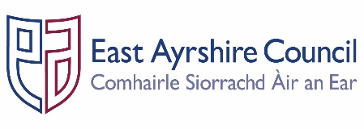
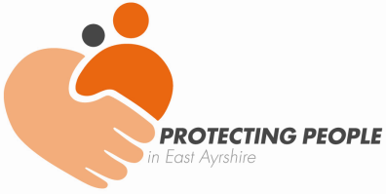
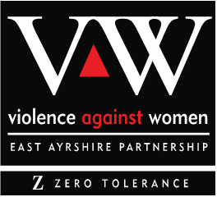


Job Outline

Post: East Ayrshire Violence Against Women Partnership – Independent Chair
Accountable to: Chair, East Ayrshire Chief Officer Group
Reporting to: Chief Executive, East Ayrshire Council or delegated Chief Officer
Professional link: Senior Manager – Protection & Learning and Lead Officer – VAWP
Job Purpose: The Independent Chair will be responsible for providing leadership, assurance, direction and co-ordination of East Ayrshire’s multi-agency Violence Against Women Partnership. The Chair is also responsible for ensuring the delivery of the priorities as set out in the East Ayrshire Violence Against Women & Girls Strategic Plan and through its vision ‘Working together to improve safety, wellbeing and equality for all women and girls in East Ayrshire.’

- KEY DUTIES & RESPONSIBILITIES

- Ensure that East Ayrshire’s multi-agency Violence Against Women Partnership fulfils its key functions to deliver the Equally Safe Strategy: Scotland’s strategy for preventing and eradicating violence against women and girls Equally Safe 2023 - preventing and eradicating violence against women and girls: strategy - gov.scot

- Ensure that the Violence Against Women Partnership fulfils its key functions as outlined in national guidance (2016) vawpartnershipguidance-aug-2016.pdf

- Chair the multi-agency Violence Against Women Partnership ensuring appropriate representation and ensure all work is undertaken in accordance with relevant legislation and policy.

- Provide leadership support for the Violence Against Women & Girls Lead Officer.

- Ensure engagement between partners and all other stakeholders by promoting and developing multi-agency working arrangements and practices in respect of violence against women and girls.

- Lead and collaborate with the Violence Against Women & Girls Lead Officer on the production of an Annual Report and Strategic Plan and other related reporting.

- Ensure that multi-agency improvement plans are in place, along with implementation arrangements and quality assurance.

- Promote the development and implementation of awareness campaigns to ensure a greater understanding of violence against women and girls through public information and engagement initiatives.

- Promote positive outcomes for women and children consistent Equally Safe’s vision and principles and within a context of continuous improvement.

- Represent the East Ayrshire Violence Against Women Partnership at a national level as required, ensuring collaboration with other Partnerships in Ayrshire and across Scotland.

- Monitor the activity and measure the impact of services provided on a multi-agency basis to support and protect women and children at risk of harm through domestic abuse.

- Support the development and delivery of a local performance framework in line with Equally Safe and the local Strategic Plan.

- Take a lead role where required in responding to media enquiries within the framework of the media protocol and in conjunction with the Violence Against Women Partnership and Chief Officer Group.

- Work with local multi-agency partners to support oversight and governance of East Ayrshire’s Multi Agency Risk Assessment Conference (MARAC).

- Support the development and delivery of local arrangements in relation to Scotland’s Domestic Homicide Review Model.

- Monitor the resource requirements to enable the Violence Against Women Partnership to function appropriately and report accordingly to the Chief Officer Group.

- GENERAL RESPONSIBILITIES

- Be accountable to the Chief Officer Group and ensure effective partnerships with all relevant agencies.

- Develop and maintain networks with the Scottish Government and other national bodies on the implementation and development of the Violence Against Women Partnership’s strategic plan.

- To ensure that the Violence Against Women Partnership collaborates with other similar Partnerships across Ayrshire and Scotland.

This description is indicative of the nature and level of responsibilities associated with this role. It is not exhaustive and the Chair may be required to undertake other duties and responsibilities from time to time.

Person Specification
Designation: East Ayrshire Violence Against Women Partnership – Independent Chair

Attributes | Essential Criteria | Desirable
Qualifications | - Degree level (or equivalent) qualification | - Relevant professional qualification  - Membership of a relevant professional body
Knowledge & Skills | - Evidence of effective leadership skills and an ability to motivate others  - An ability to engage constructively with a range of stakeholders, communicating effectively with all partners  - In-depth knowledge of the strategies, policies and guidance relating to violence against women & girls and related specialist services  - Fluent report writing and effective presentation skills  - Ability to work autonomously using own initiative and as part of a team  - Ability to analyse situations and reach independent judgements  - Good ICT skills  - Able to prioritise a workload and meet deadlines  - Strong personal values, rooted in respect and valuing people  - Able to exercise sound judgement in complex matters  - Emotionally responsive to the impact of complex work with all partners involved  - Ability to maintain confidentiality | - Knowledge of local and national government  - Knowledge and understanding of the role and function of Community Planning Partnerships  - Knowledge of the role of Violence Against Women Partnerships  - Virtual chairing and meeting delivery skills  - Evidence of continuous professional development throughout career
Experience | - Worked extensively at senior management level  - Partnership working on a multi-agency capacity or across multi-disciplinary teams  - In depth experience of working within the area of violence against women and girls, or related services, and of the strategy and policy frameworks in place  - Implementing strategies, policies, procedures and standards  - Chairing of multi-disciplinary groups and meetings  - Experience of analysing complex information | - Experience of frontline service delivery in women’s and girl’s services  - Experience of chairing multi-agency Learning Reviews  - Experience of contribution to strategic inspections

