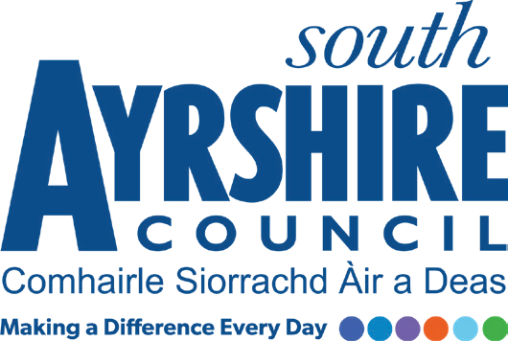




Job Purpose

Responsible for the cleaning of the premises and the supervision of cleaners.
To ensure the effective security of council buildings (schools) and their contents

Date: February 2021
Job Title Cleaning Supervisor (Term Time)

Level Grade 1 Level 3

Service Facilities Management

Job Description

Post Responsibilities:
- Supervision and training of Cleaners including Personal Development Reviews.
- Ensure adequate stock of approved cleaning materials.
- Responsible for security and welfare for all employees.
- Ensure the efficient utilisation of employees, labour and equipment.
- To liaise with external contractors as and when required.
- Complete log of any occurrences within the premises ie vandalism.
- To carry out such other duties consistent with the post as directed by the Facilities Team Leader.

Possession of:
- Basic knowledge and awareness of COSHH and Health & Safety Working practices
- Knowledge in required Manual handling skills in relation to the post

Substantiated ability to:
- Demonstrate relevant work experience relative to the role
- Maintain accurate records and co-ordinate stock control ensuring the correct distribution of all chemicals
- Work on own initiative, prioritise workload, deliver results against agreed timescales and achieve deadlines.
- Self-motivate with the skills to motivate others , with a positive approach to team work
- Meet the standards required under the Values and Behaviours of South Ayrshire Council.

Demonstrable experience of:
- Supervisory skills, and good practical skills in general housekeeping with high quality standards of cleanliness
- Fluent Communication skills, both verbally and in writing
- Reliability and enthusiasm
- Working and adapting within a flexible working environment with the ability to cover various locations across South Ayrshire Council as and when required including weekends
- Customer care with a strong commitment to providing a high standard of service delivery

In terms of the Protection of Vulnerable Groups (Scotland) Act 2007, this post is designated as
Regulated Work. Consequently, in order to undertake the duties of this post, you must hold
Membership of the Protecting Vulnerable Groups (PVG) Scheme.

If you are charged with any offence, or are involved in any activity which may have implications
For your membership of the PVG Scheme, you must immediately notify your Line Manager.

