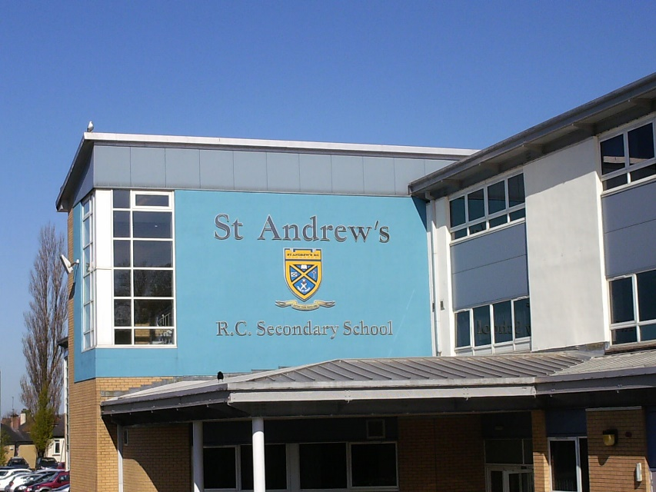

Putting Young People First

Depute Head Teacher

St Andrew’s Secondary School
47 Torphin Crescent
Glasgow G32 6QE
Phone 0141 582 0240
Fax 0141 582 0241
headteacher@st-andrews-sec.glasgow.sch.uk

St Andrew’s Secondary School: School Profile

St Andrew’s Secondary School is a six year Roman Catholic Comprehensive, which aims, in partnership with students, parents and the local community to develop our young people’s full potential. We seek to provide the highest quality teaching and learning in a safe, well-ordered and caring environment where all can develop intellectually, physically, emotionally and spiritually. St Andrew’s Secondary School is all about ‘Putting Young People First’.

Saint Andrew’s Secondary is situated in the Carntyne area of Glasgow’s thriving east end. The new school opened in 2003 and is one of the best resourced schools in the city. The combination of community and educational cooperation is strongly developed in St Andrew’s Secondary and is evident in our excellent record of exam success. The school currently caters for around 1900 students, delivering a high quality curriculum with examination expectations and actual performance in all subjects high.

St Andrew’s RC Secondary School is a Catholic Community that promotes faith, service and inclusion, providing enrichment and nurturing lifelong learning.

The Staff

The current roll is around 1950 with approximately 140 teaching staff. The Senior Leadership Team consists of the HT and 6 Depute Head Teachers, School Business Manager and Partnership manager. There are also 16 Principal Teachers of Subject/Faculty. Support Staff consists of Clerical/Admin, Pupil Support Assistants, a team of Technicians, a part-time Librarian, janitorial, cleaning and catering personnel.

Partnership

St Andrew’s Secondary School is part of the St Andrew’s Learning Community and has developed strong links with local schools and early year establishments.

St Andrew’s Secondary has a very active, strong and supportive Parent Council. The school engages with parents and the community in a number of ways including regular parents’ evenings, newsletters and our Twitter feed.

Person Specification: Depute Head Teacher
Reports to | Head Teacher, St Andrew’s Secondary School
Reference Number
Grade | Depute Head Teacher 9
Hours | 35 hours per week
Status | Permanent
Location | St Andrew’s Secondary School, 47 Torphin Crescent, Glasgow, G32 6QE
Closing Date | As Advert
Interview Date | To Be Confirmed

General Duties and Responsibilities of Depute Head Teacher
Key Area | General responsibilities and duties
Strategic Vision, Values and Aims | Responsibility for the leadership, good management and strategic direction of a team of staff responsible for supporting the learning and pastoral care of children and staff.  Providing curricular leadership.  Promoting staff development and providing professional advice and guidance to colleagues.
Teaching and learning | Responsibility for leading the development and delivery of a curricular, learning support or pastoral care programme suitable to meet the needs of all pupils, as dictated by the School Improvement Plan.
Quality Assurance and School Improvement | Leading and managing the development, promotion and implementation of the school’s arrangements for self evaluation and overall school improvement.  Leading and implementing policies within area(s) of responsibility.
Contribution to Positive School Ethos | Promoting positive behaviour and emotional wellbeing strategies across the school.  Leading on and contributing to and promoting the development of a positive school ethos.  Leading on and contributing to the development, promotion and implementation of school policy and procedures.
Implementation of Pupil Support Strategies | Contribute to the development, promotion of, and implementation of school policy and procedures in relation to arrangements for supporting pupils.
Partnership Working | Liaising with external agencies to support children and staff in developing a safe, nurturing and happy school.  Promote partnership working with professional and support staff, parents/carers and appropriate agencies.

Any other duties as directed by the headteacher.

Person Specification: Depute Headteacher Secondary

ESSENTIAL | DESIRABLE

Qualifications
GTC Standard for Full Registration. | Additional qualifications or professional recognition. Catholic Teaching Certificate

Leading Learning in Glasgow
Experience of working in a promoted post or equivalent.  Teaching experience across S1-S6 stages.  Involvement in promoting and achieving an ethos for effective learning.  Knowledge of current initiatives.  Experience of leading and managing a major curriculum change.  Evidence of inspiring and motivating others.  Evidence of managing resources to effectively provide quality learning experiences for all. | Involvement in developing a school in terms of vision, values and aims.  Evidence of success in engaging all stakeholders in children’s learning and the life of the school.

Raising Attainment and Achievement in Glasgow
Evidence of raising standards of attainment and improving the overall quality of learners’ achievements.  Commitment to ensuring that education of the highest standard is delivered to all pupils.  Has contributed to staff development to enhance school performance.  Has made a significant contribution to a School Improvement Plan.  Experience in the management of quality assurance processes to improve outcomes for learners.  Actively involved in promoting school priorities and developing the full potential of children, staff and parents. | Actively involved in promoting council priorities and developing the full potential of children, staff and parents.  Able to evidence commitment to continuous change.  Success in using quality assurances processes to improve outcomes for learners.

Person Specification: Depute Headteacher, cont’d

ESSENTIAL | DESIRABLE

Supporting Glasgow’s Learners
Can demonstrate significant experience of the Secondary curriculum, learning and teaching and meeting the needs of all learners including those with additional support needs.  Significant experience in planning, organising and co-ordinating major school issues.  Evidence of working in partnership to improve outcomes for learners. | Evidence of supporting colleagues to meet the needs of all learners including those with additional support needs.  Experience of leading staff development to meet school and individual needs.

Working Together in Glasgow
Experience of engagement in a range of areas of school life.  Experience of developing partnerships with children, parents/carers, outside agencies and the wider community.  Involvement in presenting to a variety of audiences. | Ability to promote effective teamwork and partnerships.  Experience of good communication in planning, organising and coordinating school activities.  Evidence of relevant skills in managing people, policy development, planning and resources.

Glasgow City Council
Education Services
City Chambers (East)
40 John Street
Glasgow G1 1JL

0141 276 9914 (option 2)
www.glasgow.gov.uk

