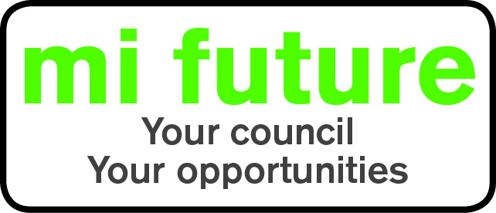

Generic Role Profile Strengths – C9

Midlothian Council has adopted a behavioural style of interviewing. Our interviews are structured and are strengths based, that is we search for a number of characteristics or skills, that we have identified as being important for success in the role in question.
Below are the strengths identified for the post you are applying for:-

Strengths for Matching

Persuasive - Is comfortable negotiating and likes to influence other people’s views.
Controlling - Likes to be in charge, take the lead in stations and tell others what to do.
Evaluative - Evaluates information, identifying potential limitations or errors.
Outspoken - Freely expresses opinions, makes disagreement clear and is prepared to challenge others, rather than holding back.
Vigorous – Thrives on activity, and enjoys having a lot to do.
Innovative – Enjoys generating new ideas, being creative, and thinks of original solutions.
Decisive –Reaches conclusions quickly and makes fast decisions.

