DALZIEL HIGH SCHOOL


Dalziel High School is a non-denominational, six-year comprehensive school situated in Motherwell, close to Strathclyde Park.

Originally opened in 1898, it has had a long and distinguished history. Over the years, Dalziel has provided a consistently high standard of education for all its pupils and has enjoyed a well-deserved reputation as a sound educational establishment. The school continues to thrive and remains a source of great pride within the community - so much so that, for the last number of years, placing requests have outnumbered the places available.
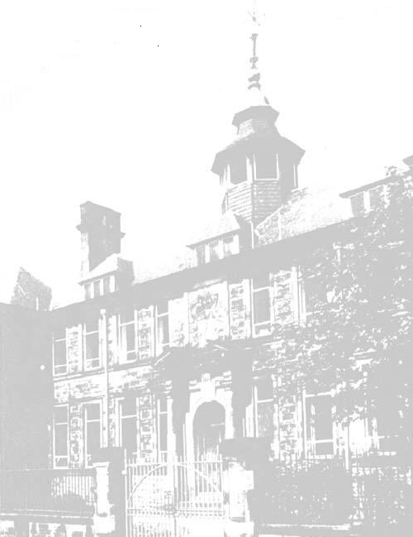

Dalziel High School
Crawford Street
MOTHERWELL
ML1 3AG

Tel: 01698 274900

Fax: 01698 328631

School Values

Dalziel High School aims to create an atmosphere and learning environment where all pupils are given equal opportunity to realise their maximum potential – personally, academically, physically and culturally. The values which underpin these aims are:


Respect
At Dalziel High School, respect is ingrained in our daily interactions. We foster an environment where every individual, regardless of their background or beliefs, is treated with dignity and kindness. Young people and staff alike demonstrate respect by actively listening to others, valuing different perspectives, and practising empathy. We embrace diversity and actively promote inclusivity, ensuring everyone feels valued and respected in our school community.


Include
Inclusion lies at the heart of our ethos. We strive to create an environment where every young person feels a sense of belonging, knowing that their unique strengths and contributions are valued. We actively seek out opportunities to include and involve all young people in academic, social, and extracurricular activities. By embracing diversity and fostering a culture of acceptance, we celebrate the rich tapestry of our school community and empower each young person to reach their full potential.


Achieve
At Dalziel, we have a relentless pursuit of excellence. We inspire and challenge our young people to set high goals and provide them with the necessary support to achieve these. We cultivate a growth mindset, encouraging young people to persevere through challenges and learn from setbacks. By fostering a culture of continuous improvement, we empower our young people to strive for personal and academic success. Through hard work, dedication, and a commitment to excellence, our young people achieve their goals and unlock their full potential.

SUMMA PETENDA
‘aim for the highest’

The school has three associated primaries - Knowetop, Glencairn and Ladywell - with many pupils coming to the School on placing requests. The School Roll is at maximum and, by virtue of this, most classrooms are in use every period.

The teaching staff numbers around 65 with the Senior Leadership Team comprising of the Rector and five Depute Rectors. On the curriculum side, there are 10 Principal Teachers. Pupil Support is organised in 3 Houses with the Pupil Support Team comprised of 3 PTs - one per House - and many other members of staff who have a Pupil Support commitment.

Dalziel High School has a Deaf Education Department which is staffed by 3 teachers and is under the line management of one of the Depute Rectors.

Staff-pupil relationships in Dalziel are excellent, and these are characterised by genuine warmth as well as mutual respect. Visitors often remark that they feel a sense of calmness and friendliness about the school on coming through the front door. It is, without doubt, a very good school in which to work - but it is, by no means, an easy school in which to work. Classes are invariably large (many at maximum size) and all associated with the school have high expectations.

Dalziel has a strong tradition attached to it - a tradition which is very much alive and well reflected in the multitude and variety of extra-curricular activities associated with the school. These do not involve simply the spectrum of ‘normal’ activities eg football, rugby, orchestra, choirs, chess, guitar etc but also extends to School Shows (Junior and Senior), School Sports, School Magazine, Public Speaking, Quizzes, Dances, Burns Supper, Talent Show etc, all of which are hugely popular and extremely well supported. This generates further enthusiasm and gives a great feeling of satisfaction and pleasure to all associated with them.

The successful candidate, therefore, will require to show the same commitment and enthusiasm to join in all aspects of life and work in Dalziel that is the hallmark of the present staff.

